Part 1 - Overview of Fabric CI/CD
Microsoft Fabric is a unified analytics platform designed to bring together different data and analytics tools into a single, integrated software-as-a-service (SaaS) solution. Microsoft Fabric caters to data engineers, data scientists, and analysts who need to collaborate on analytics and AI projects. The Fabric platform adds value by reducing complexity while still making it possible to build, deploy and manage enterprise-scale projects focused on analytics and AI.
The Microsoft Fabric platform attracts people with different technical backgrounds. For example, there are data engineers tasked with creating notebooks to ingest and transform data to populate lakehouse tables. There are data modelers tasked with building and refining semantic models on top of lakehouse tables. There are report designers tasked with authoring and updating Power BI reports that are built on top of those semantic models. Once you understand how CI/CD works in Fabric, you will be able enable collaboration which allows all these people to continually update their part of a Fabric project without stepping on anyone else’s work.
This article is written to provide guidance to data engineers, release managers, Fabric administrators and professional developers building end-to-end solutions on the Fabric platform. This article explains how to setup the CI/CD infrastructure for analytics and AI projects in Fabric as well as how to deploy and manage the CI/CD lifecycle of workspace items such as lakehouses, notebooks, pipelines, semantic models and reports. This article starts with an overview of the Fabric CI/CD landscape covering essentials concepts and features. After this overview, the article will move through the steps of setting up a real-world Fabric CI/CD project which enables collaboration and provides a structured release process.

Quick Review of Traditional CI/CD Fundamentals
CI/CD represents a set of core principles and best practices that have been widely adopted across the software industry. The goal of CI/CD is to streamline and accelerate the lifecycle of software development. CI/CD focuses on two different aspects of managing the application lifecycle which are continuous integration (CI) and continuous deployment (CD).
Continuous integration (CI) is the practice of merging code changes into a shared repository on a regular basis. Each time developers merge their changes, it can trigger automated workflow processes that ensure the application source code as a whole still works together by running validation tests. Continuous integration makes it possible to detect bugs early on. This, in turn, makes it possible to maintain a codebase that's always in a working state and ready to deploy to production.
Continuous integration is popular because it allows a team of developers to work on the same application at the same time. CI/CD solves the challenging problem of integrating the work of multiple developers into a shared codebase in an ongoing basis. Once you have designed and implemented a GIT branching strategy, you’ll be able to merge everybody’s changes together in a structured process that maintains code quality while also getting updates and new features into production as quickly as possible.
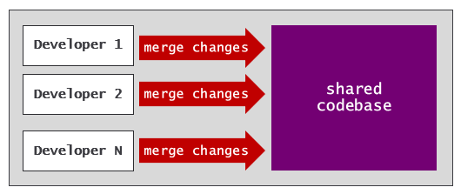
Continuous deployment (CD) is the practice of automating the deployment of code. Deployment is often preceded by some type of interactive human approval process. Once a proposed set of changes has been approved, a continuous deployment process is automatically triggered to deploy these changes to a target environment.
With continuous deployment, you can build automated processes to route the lifecycle of application code through a sequence of environments. Promoting code changes through environments provides opportunities for enhanced testing and for interactive approval processes that ensure only high quality code reaches production. The release process in a CI/CD workflow is often built using a standard set of environments such as dev, test and prod.
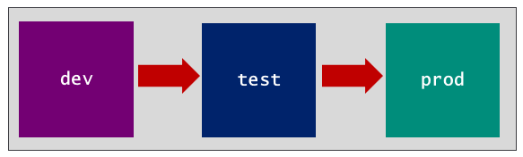

Fabric CI/CD Capabilities
The Fabric platform provides the following capabilities and features to assist with CI/CD.
- GIT Integration
- Deployment pipelines
- Variable libraries
- Workspace Item Types
- Item Definitions
This section will drill into each of these capabilities to build your understanding of how they fit together into the big picture.

GIT Integration
The Fabric CI/CD infrastructure starts with its support for GIT integration. Imagine you’re on a team building a data analytics solution based on a Fabric workspace that includes a lakehouse, notebook, semantic model and report. Fabric makes it possible to maintain the source code for all four workspace items as a single source of truth in a GIT repository. Any updates made to workspace items can be versioned, tracked and compared to other versions.
Fabric's list of supported GIT providers includes Azure DevOps, GitHub and GitHub Enterprise. Microsoft is currently planning to add other popular GIT providers in the future. You can find the most up-to-date information about Fabric's support for GIT providers and their limitations by reading Supported Git providers.
Fabric’s support for GIT integration is enabled at workspace scope. More specifically, you enable GIT integration by connecting a workspace to a branch in a GIT repository. If you navigate to the Git integration tab of the Workspace settings dialog, you can work through the steps to connect a workspace to a branch in a GIT repository. The first step is to select a GIT provider such as Azure DevOps or GitHub.
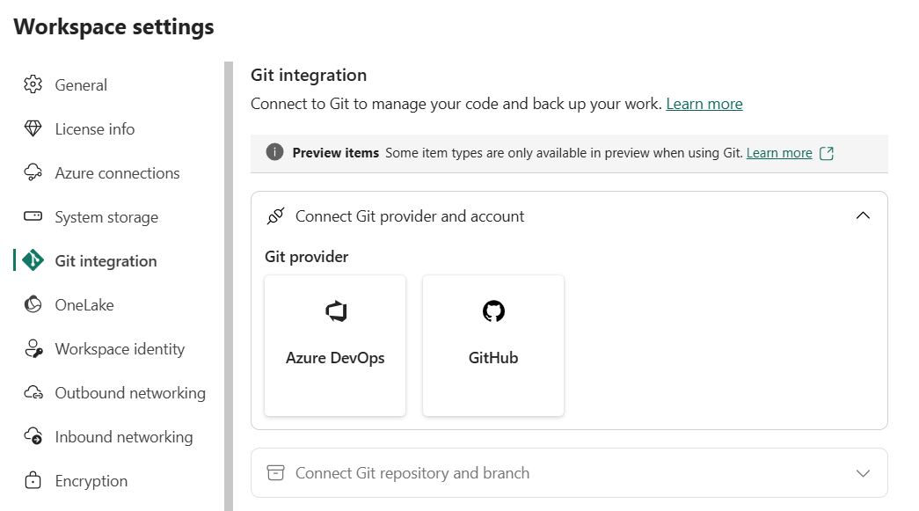
Before connecting a workspace to a branch, you need to create a Fabric connection to the target GIT repository. Fabric provides one connector for creating Azure Dev Ops source control connections and another connector for creating GitHub source control connections. When creating a connection to an Azure DevOps repository, you can configure connection credentials using a service principal. When creating a connection to GitHub, you must configure the connection credentials using a personal access token (PAT).
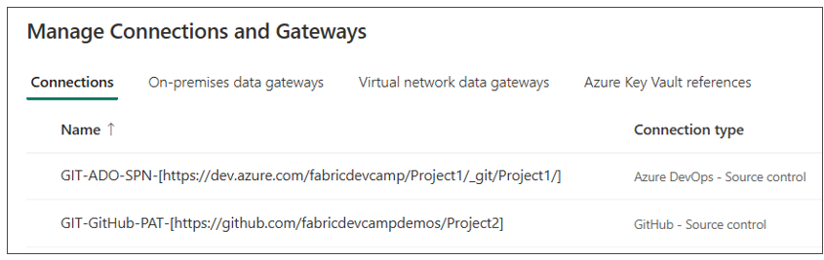
It is a best practice to create GIT source control connections using service principal credentials. It is also recommended to create GIT source control connections using the Fabric REST APIs or a tool such as Terraform. This best practice will be revisited in the walkthrough in Part 2 - Deploying a Fabric CI/CD Project.
If you select Azure DevOps as the GIT provider and create a source control connection to the target Azure DevOps repository, you can then select an Organization, Project, Git repository and Branch. Optionally, you can include a Git folder setting.
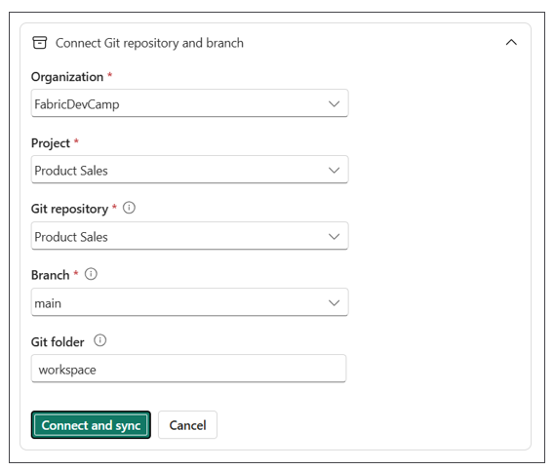
Specifying a Git folder setting allows you to avoid storing the folders containing workspace item definitions in the root folder of the target repository. Using a Git folder setting is recommended in scenarios where you need to add other project files to the same GIT repository. In a Fabric CI/CD project, it's common to add YAML files for defining workflows as well as other types of files used to implement workflow logic such as shell files, PowerShell files and/or Python files. By configuring a GIT folder setting, you avoid the confusion mixing the workspace item definition files together with other types of project files.
This examples shown in this article will use Git folder setting of workspace. However, you can use any name you’d like.
Now imagine you have deployed a data analytics project to a workspace which includes a lakehouse, a notebook, a semantic model and a report. When you first connect the workspace to a GIT repository, Fabric will generate an item definition for each workspace item which it commits to the target GIT branch as a named folder containing definition files. If you used a GIT folder setting of workspace, you should see a top-level folder named workspace with a child folder for each workspace item. The Fabric workspace UI provides a GIT status column that displays Synced indicating all workspace items are in sync with the item definitions stored in the GIT repository.
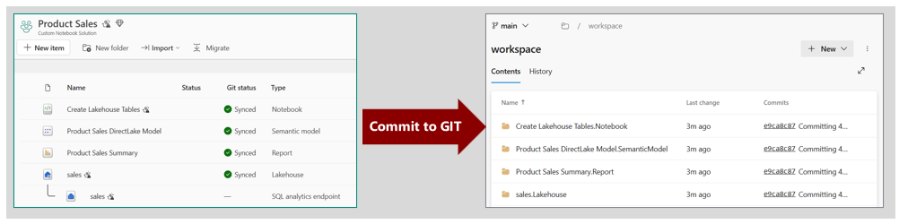
Fabric uses a naming convention for workspace items which includes item display name, a period and the item type in the format of [Item Display Name].[Item Type]. You can see from the previous screenshot that GIT synchronization creates folders using this naming convention for folder names such as sales.Lakehouse and Product Sales Summary.Report.
The GIT folder setting also makes it possible to connect multiple workspaces to a single GIT branch. Consider a scenario where a Fabric solution is spread out across two workspaces with a staging workspace and a presentation workspace. The staging workspace can be connected to a branch with the Git folder setting of workspace/staging while the presentation workspace can be connected to the same branch with a Git folder setting of workspace/presentation. Even though this type of solution is spread out across multiple workspaces, the source code for the entire solution is tracked in a single branch.
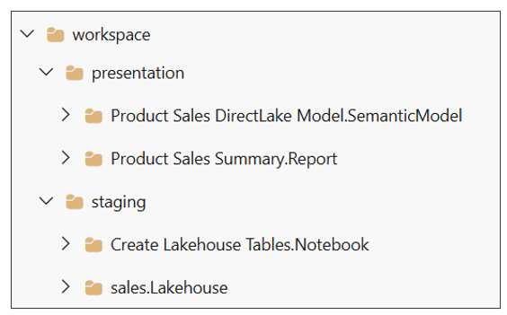

GIT Synchronization
In the simplest use case, you can connect a workspace to a GIT repository with a single branch. This minimal setup allows you to start taking advantage of the capabilities of Fabric GIT integration. For example, you have the ability to version workspace items. You also have a backup mechanism giving you the ability to revert to previous versions of a workspace item if something goes wrong with an update.
Let's say you have a workspace and you have connected it to a GIT repository with a single branch named main. At first, the items in the workspace are in sync with the item definitions in GIT. Next, you open a report in the browser, navigate to edit mode and make a few changes. Once you save your changes, the updated report is no longer in sync with the item definition in GIT. The Fabric workspace UI displays a Source control button in the upper right shows that indicates there is a workspace item with uncommitted changes. You can also see the Git status column for the report displays Uncommitted.
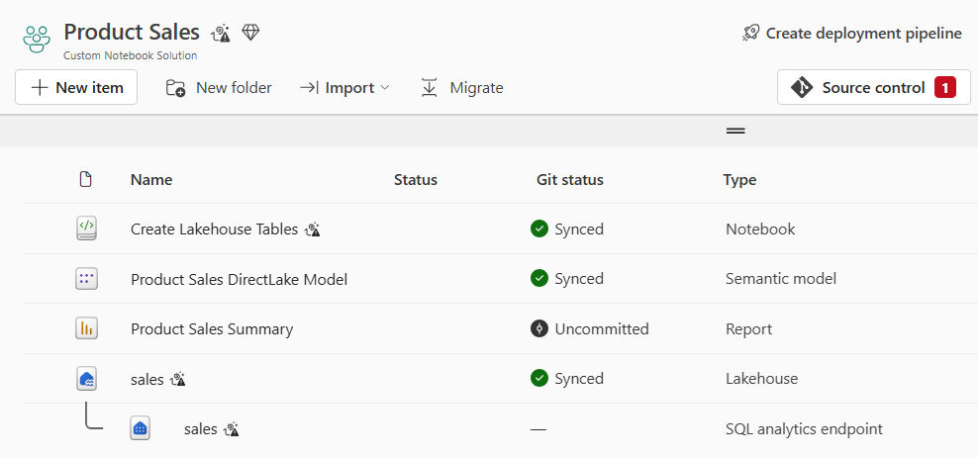
If you update a report in the browser, the Git status for that item will continue to display Synced until you first save your changes by invoking the Save command. Other types of workspace items exhibit auto-save behavior and don't require an explicit save operation before they begin to show a Git status of Uncommitted.
If you click the Source control button, that will open the Source control pane on the right side of the page. The Source control pane has two tabs named Changes and Updates. The Changes tab shows the workspace items which have changes that have not yet been committed to GIT.
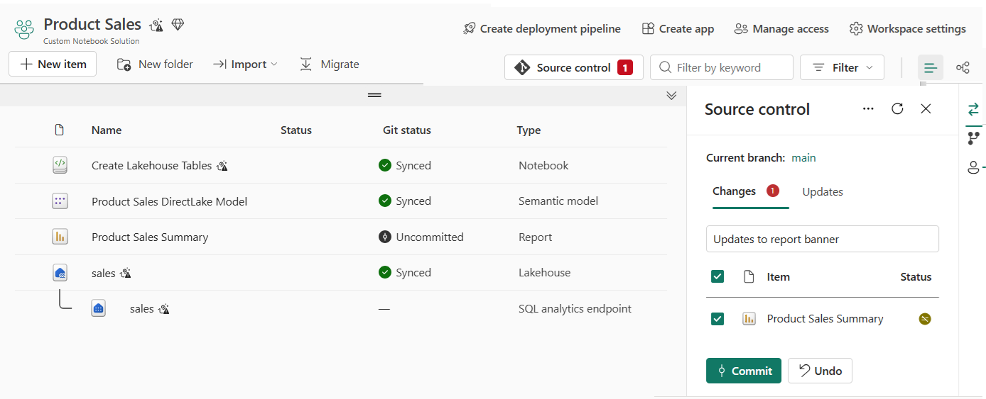
What happens if you made a mistake while editing the report and accidently saved your changes? You can click the Undo button to return the report to its previous state before you started editing. Clicking the Undo button will discard any changes made to the workspace item and return it to its previous state by synching with the underlying GIT branch.
Once you have made updates to the report and saved the changes, you can click the Commit button. Clicking the Commit button runs a Commit To GIT operation which pushes the workspace item changes to the underlying GIT branch. You should take note that there is a small textbox at the top of the Changes tab. This textbox allows you to enter a commit message which gets recorded in GIT. While the Fabric UI does not enforce adding a commit message, you should always have the discipline to enter a useful and descriptive message about what is being committed. If you leave the textbox empty, Fabric generates a generic commit message which doesn’t really indicate what was updated or why.
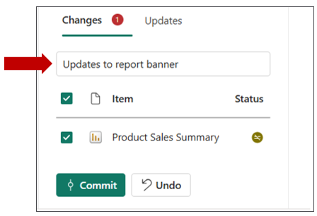
You have seen that you can run a Commit to GIT operation to push workspace item changes to a GIT branch. However, you can also synchronize changes in the other direction. Think about a scenario in which a workspace is synchronized with a GIT branch. After that, new changes are merged into the branch from a source other than the workspace item. You can use an Update from GIT operation to synchronize workspace items with changes merged into the underlying GIT branch.
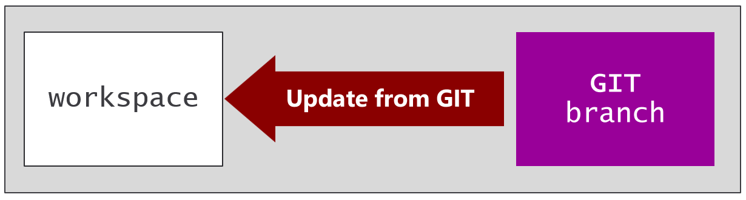
Consider a scenario in which you have updated a report and committed your changes to GIT. After that, you realize that there is a problem with the update and you'd like to roll it back. You can go to the GIT repository and revert the commit that contains the undesirable changes. Reverting a commit is often accomplished using a pull request which makes the reverted commit appear as new changes within the branch. When Fabric detects new changes in the underlying GIT branch, it determines that the report is no longer in sync and the Git status column displays Update Required.
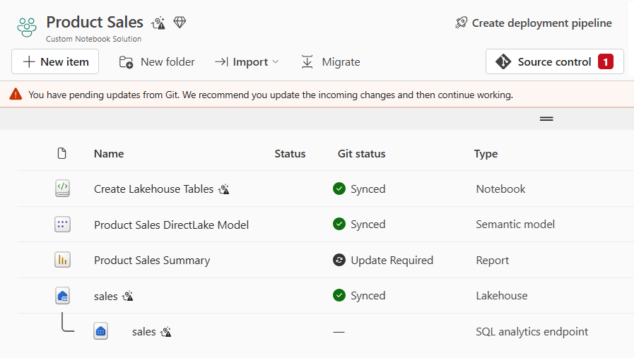
You can update the report by navigating to the Updates tab of the Source control pane and clicking the Update all button. Clicking Update all will run an Update from GIT operation to synchronize the report by applying the changes merged into the branch. This will effectively roll back the changes to the report that were previously commit to GIT.
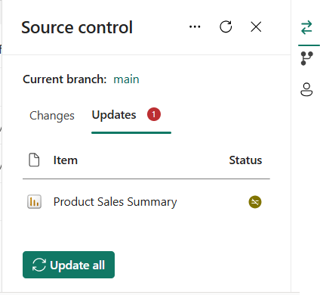
You have now seen that GIT integration allows you to synchronize updates in two different directions. After you've updated a workspace item, you can commit those changes to GIT. You can also update from GIT to keep workspace items in sync with changed merged into the underlying GIT branch. However, GIT integration in Fabric allows you to go on step further. You can create an empty workspace and initialize it using an Update from GIT operation which uses the items definitions in a GIT branch to create a matching set of workspace items.
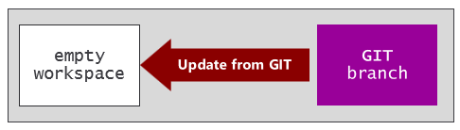
Consider a scenario in which the prod workspace is connected through GIT integration to a repository with a single branch named main. You have just received a request from the business team to perform updates on a specific report. However, you don't want to perform these updates by editing the report in the prod workspace where business users will continue to access the current version. Instead, a better approach is to create a new, isolated workspace for development. This will allow you to perform updates and test your changes without affecting anything user can access in the prod workspace.
To set up an isolated development environment, you can create a new workspace named dev1 and connect it to the same GIT branch named main. When you connect the dev1 workspace to the same branch with the same Git folder setting as the prod workspace, Fabric will react by automatically creating a set of workspace items in the dev1 workspace to match the set of workspace items in the prod workspace.
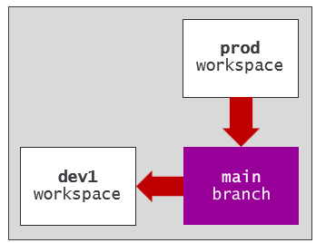
When you initialize an empty workspace using a Update from GIT operation, the workspace usually requires additional configuration before it's ready for development purposes. This is an important topic that will be revisited shortly.
A key observation is that the dev1 workspace provides a development environment that is isolated from the prod workspace. You can make edits to the report in the dev1 workspace without affecting anything in the prod workspace. After completing the updates on the report, you can save your work. After that, you can run a Commit to GIT operation to commit the changes from the report item in the dev1 workspace to the report definition in the main branch.
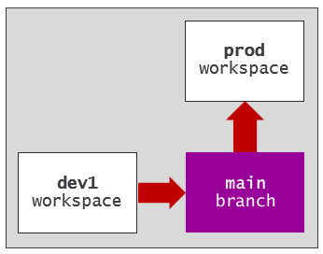
Once changes are committed to the main branch, the report item in prod workspace will show a GIT status of Update required. Now, you can click the Update all button to run an Update from GIT operation which will synchronize changes from the report definition the main branch to the report item in the prod workspace.
Instead of synchronizing these changes by hand, you can develop a workflow that is triggered automatically whenever changes are merged to main which automates the process of synchronizing changes to the prod workspace.
If you are new to working with GIT, you must be mindful of avoiding merge conflicts. A merge conflict occurs in Fabric when changes are made independently to both a workspace item and its corresponding item definition in GIT. You can update one or the other, but you can't update both without causing a merge conflict. When Fabric detects a workspace item has a merge conflict, the Git status column displays Conflict and the Commit button is disabled for that workspace item. When you experience merge conflicts, you must take some type of corrective action to resolve them before you can commit your changes.
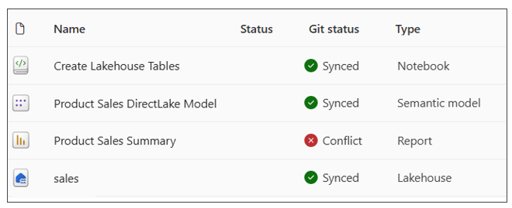
Resolving merge conflicts in Fabric
- Resolve conflict in a Fabric workspace
When you have multiple workspaces connected to a single GIT branch, there is an increased risk of merge conflicts. You must have the discipline to ensure changes flow in only one direction. As an example, let's say you've updated the report in the dev1 workspace but haven't yet committed your changes to GIT. What happens if someone else updates the same report in the prod workspace and commits those changes to the main branch? This will create a merge conflict which restricts you from being able to commit the changes you've made in the dev1 workspace.
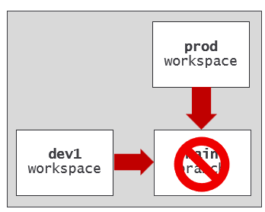
A development model which involves merging all changes into a single GIT branch is known as trunk-based development.
Trunk-based development provides the ability to conduct development work in isolated workspaces while avoiding the complexity and overhead of a multi-branch strategy and pull requests. Since there is only one branch in trunk-based development, it eliminates the risk of merge conflicts between branches. Trunk-based development offers the benefit of providing the quickest and most direct way to publish changes into production.
Trunk-based development also has its drawbacks. It requires a team of disciplined and experienced people that know what they are doing. Anyone can merge whatever changes they want directly into the main branch at any time. With trunk-based development, there isn't much control over what changes get merged into the production codebase. The alternative approach to trunk-based development is to adopt a multi-branch strategy based on feature branches and pull requests.

Feature Workspaces
The use of features branches has become widely adopted in software development due to popular branching strategies such as Gitflow or GitHub Flow. A branching strategy which includes feature branches allows developers to work and commit changes in isolation. You can also configure a feature branch with workflows that are triggered whenever changes are committed. These workflows can automate running tests with linters, validation checks and security scans as part of the continuous integration process to improve the quality of code that reaches production.
After committing changes to a feature branch, the next step is to create a pull request to merge those changes to the shared branch. You can think of a pull request as a proposal that allows collaborators and release managers to review a proposed set of changes. GIT providers such as Azure DevOps and GitHub make it possible to configure pull requests with interactive approval processes that are as simple or as complex as required for a given scenario. When the approval process completes successfully, the changes are automatically merged to the shared branch which is known as the release branch.
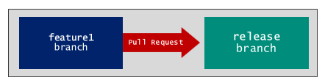
The release branch is an essential concept in continuous integration. The release branch is the shared branch where everyone's changes are merged together. It's called the release branch because its contents represent the single source of truth that is always ready for deployment to test and production environments.
The release branch is a concept not a name. A release branch is typically given a name such as main or dev.
Creating and managing pull requests
- Create pull requests in Azure Dev Ops
- Creating a pull request in GitHub
For developers migrating to Fabric with experienced in traditional CI/CD, some aspects of Fabric CI/CD will be familiar while other aspects will not. For example, developers with traditional CI/CD experience are already familiar with feature branches and pull requests. From the perspective of traditional CI/CD, creating a feature branch is a quick, inexpensive operation that allows you to get up and running right away. Things are different in a Fabric CI/CD project because each feature branch must be paired up with a feature workspace.
Think about the requirements to create a new feature workspace for development. In addition to permissions in the GIT repository, the developer requires permissions in Fabric to create a new workspace and to assign that workspace to a Fabric capacity. There's also a requirement to create or reuse a GIT source control connection which is required to connect the feature workspace to the target feature branch.
When you create a GIT source control connection to connect a workspace to GIT, the connection is created with a path to the repository. However, this path does not include anything specific about the branch. That means you can create a single source control connection to Azure DevOps or GitHub and then use that connection to connect multiple workspaces to any number of branches in a target GIT repository.
Consider a scenario in which you have connected the prod workspace to the main branch in GIT repository. The main branch acts as the release branch tracking the single source of truth. If you create a new branch from main named feature1, this new branch will initially contain an identical copy of each workspace item definition in main. Next, you can create an empty workspace named featue1 and connect it to the feature1 branch. This triggers Fabric to run an Update from GIT operation which automatically populates the feature workspace with a matching set of workspace items.
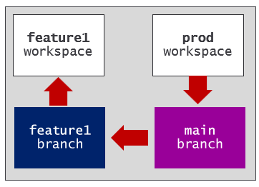
When you initialize a feature workspace with an Update from GIT operation, you're often required to complete additional configuration steps before it's ready for development. This topic will be revisited shortly in the discussion of automation.
The following diagram shows a high-level view of a development process built using feature workspaces. Each feature workspace is connected to its own feature branch. Changes to a feature workspace are first committed to the underlying feature branch. After that, you need to create a pull request to merge the changes into the release branch.
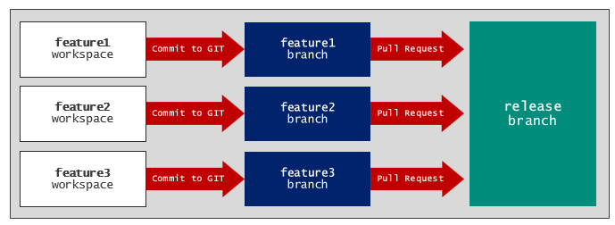
Keep in mind that feature branches should be short-lived. You don't want a feature branch hanging around too long because that increases the risk of merge conflicts with the release branch. It's a common practice to delete a feature branch as soon as a pull request completes and its changes have been merged into a release branch.
When it comes to managing the lifecycle of feature workspaces, you have a few options. One option is to manage the feature workspace lifecycle to coincide with feature branches. When using this approach, you delete both the feature branch and the feature workspace after a pull request completes and pull request's changes have been merged.
A second option is to delete the feature branch but to keep the feature workspace around for use with other feature branches. For example, you can create a feature workspace for a specific person or team working in a particular area. If you are working with several teams, you can create one feature workspace for the Spark team working with notebooks and lakehouses. You can create a second feature workspace for the data modeling team working with semantic models. You can create a third feature workspace for the analytics teams who will be continually updating reports.
The Fabric UI provides built-in commands for creating and managing feature workspaces and their connection's to feature branches. When you navigate to the Source control pane, it displays the Update and Commit panel by default. If you click the Branches tab in this navigation menu, the Source control pane displays the Branches panel.
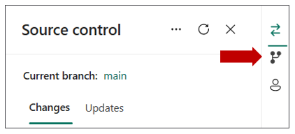
After navigating to the Branches panel, the Source control pane displays a dropdown menu with branching commands.
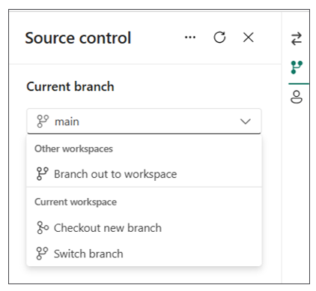
When you run the Branch out to workspace command, Fabric prompts you with a dialog with options for creating a new feature branch and connecting this branch to a new or exiting feature workspace. Remember that creating a new feature workspace requires that the user has permissions to create a workspace and to assign that workspace to a Fabric capacity.
The Switch branch command allows you to switch the connection for the current workspace from one branch to another in the same repository. Before switching to another branch you must either commit or discard any uncommitted changes in the workspace. When switching to a different branch, Fabric runs an Update from GIT operation which can involve adding, updating and/or deleting workspace items in the current workspace.
The Check out new branch command runs a set of operations that can assist with resolving merge conflicts between a feature branch and the release branch. This command allows the user to switch from the current branch to a new branch without having to discard any changes in the current branch. This command is used to resolve merge conflict scenarios.
More info on branching in the Fabric UI
- Branch out to workspace
- Switch branch
- Resolve conflict in git using Checkout new branch

Deployment Pipelines
The Fabric platform provides Deployment Pipelines as a continuous deployment mechanism to help manage the lifecycle of workspace items. The key concept behind Deployment Pipelines is that changes to workspace items can be deployed through a set of stages where each stage represents a specific environment implemented using a Fabric workspace.
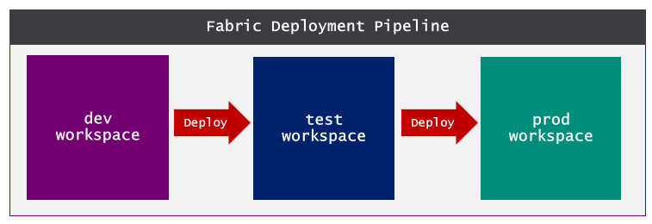
Deployment pipelines are designed to assist with continuous deployment in building a release process. You must keep in mind that release process only covers the second half of full CI/CD lifecycle. The use of Deployment Pipelines should be combined together with Fabric GIT integration to fully implement a complete end-to-end solution.
For example, you can design the development process using feature workspaces and feature branches where changes are merged back to a release branch. Updates in the release branch can be synchronized up to workspace items in the dev workspace which represents the first stage of a Deployment Pipeline. Once changes from the development process have been propagated to the dev workspace, the Deployment Pipeline is used to implement a release process to deploy changes to the test workspace and then on to the prod workspace.
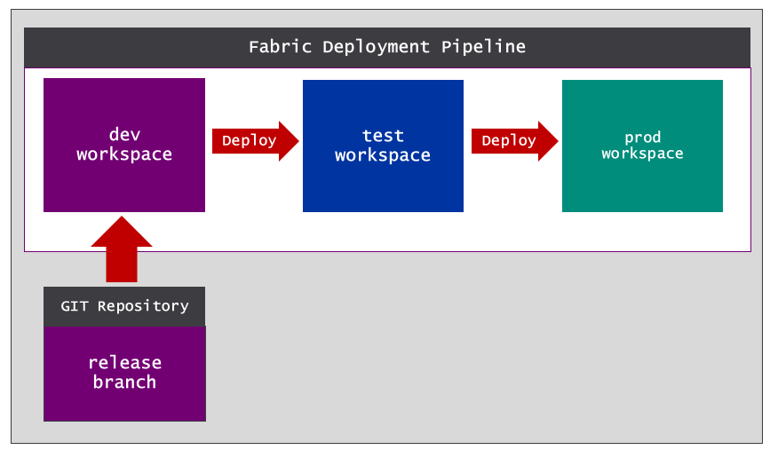
Deployment pipelines were designed to enhance productivity by hiding many of the low-level details of pushing workspace item changes across workspaces. Deployment Pipelines provide one out of several options you have for building a release process. This is an import topic that will be revisited after you learn a little more about Fabric CI/CD fundamentals.

Variable Libraries
An essential aspect of the CI/CD lifecycle involves promoting changes through a sequence of environments. The canonical example is a release workflow which moves changes through environments such as dev, test and prod. When you need to test and validate code for a project across multiple environments, it’s essential to find an effective parameterization strategy for environment-specific settings.
The Fabric platform provides the variable library to assist with parameterization. The variable library is a creatable type of workspace item in which you can define a set of variables. Other workspace items such as notebooks, pipelines, copy jobs and dataflows can be defined to read variable values from a variable library. This makes it possible to avoid hardcoding configuration settings into your code that change across environments.
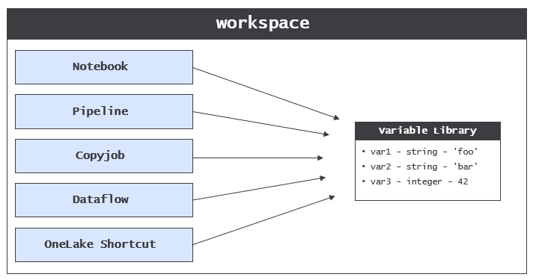
Consider the classic scenario in which you need to build a release process that moves changes through a sequence of workspaces each of which represents an environment such as dev, test and prod. The problem is that code in different workspaces must be configured with different settings to connect to a different database. To solve this problem, each workspace requires access to its own unique connection settings.
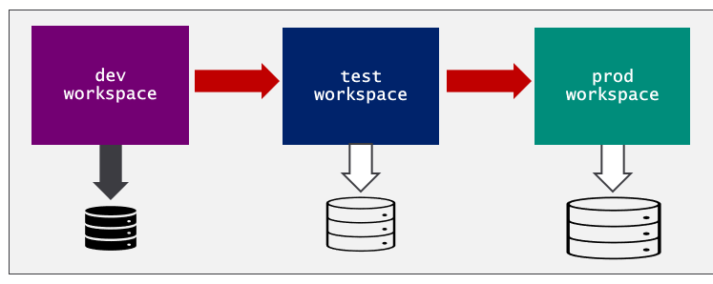
The variable library was designed to solve the problem of parameterizing these types of settings across workspaces. A variable library allows you to avoid hardcoding the configuration settings required to connect to a database. Consider a scenario in which you must write Python code in a Fabric notebook to connect to a SQL database. The thing you want to avoid is hardcoding these configuration settings into your code as literal strings.
database_server = 'devcamp.database.windows.net'
database_name = 'ProductSalesDev'
The obvious problem is that these hardcoded settings are specific to a single environment. As an alternative, you can leverage a variable library to enable support for parameterization. You start by creating a new variable library with a display name such as environment_settings. Next, you can add two string variables named database_server and database_name.
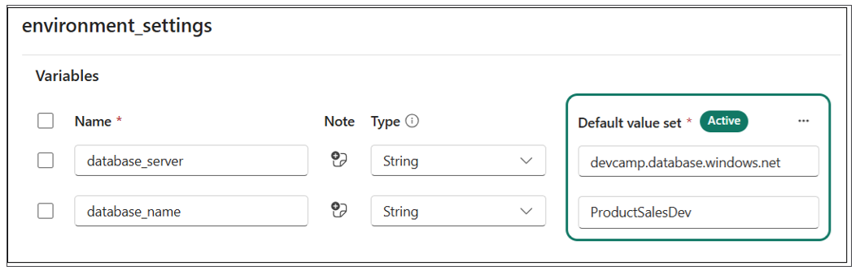
Once you have created the variable library with the two variables, you can remove the hardcoded configuration values from the notebook and replace them with code to read the variable values at run time.
database_server = notebookutils.variableLibrary.get("$(/**/environment_settings/database_server)")
database_name = notebookutils.variableLibrary.get("$(/**/environment_settings/database_server)")
You have learned that a variable library allows you to add variables. That's probably not too surprising. However, variable libraries have another important dimension used to provide parameterization support across workspaces. More specifically, Fabric allows you to extend a variable library using value sets.
Let's take a step back to build your understanding of why value sets are important. You've learned that a variable library is a collection of variables where each variable is defined with a name, a type and a default value.
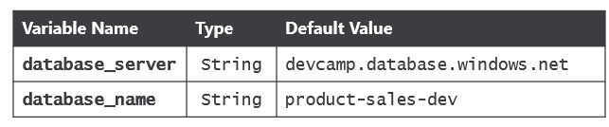
The purpose of a value set is to provide an alternate set of values for each of the variables in the variable library. Consider an example of a variable library in which the default values have been configured for the dev environment. You can extend the variable library by adding a value set for the test workspace and a second value set for the prod workspace.
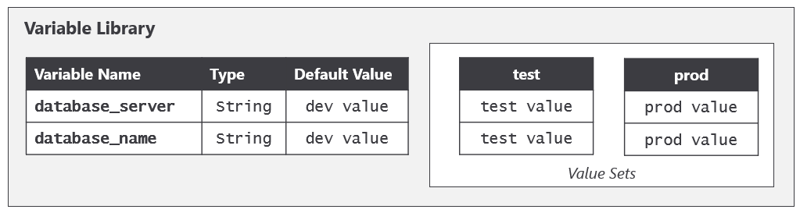
The item definition for a variable library includes variables and values sets. However the item definition does not contain anything to indicate which value set is active. That's because Fabric maintains a separate workspace-level setting that tracks which value set is active in the context of that workspace. That means three different workspaces could each contain a variable library with an identical item definition, yet each workspace can be configured to use a different value set.
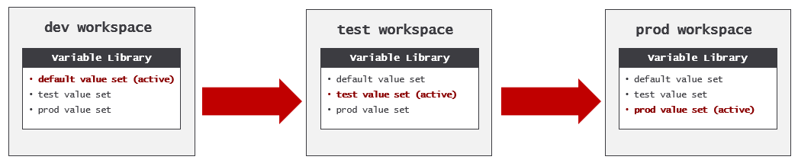

Workspace Item Types
You can think of workspace items as the building blocks used to build a Fabric solution. The workspace items that compose a Fabric solution can be deployed to one or more workspaces to provide specific data analytics or AI functionality to its users.
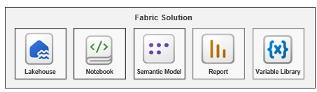
In Fabric, each workspace item has an underlying workspace item type which defines its capabilities and the user experience it provides in the Fabric service. Examples of workspace item types include Lakehouse, Notebook, DataPipeline, Semantic Model and Report. However, this is just a small sampling of the workspace items types made available when you are building solutions on the Fabric platform.
The core abstraction of the workspace item type in Fabric is what allows artifacts from different Fabric workloads to behave in a similar and consistent manner. For example, each workspace item type provides the GIT synchronization capability to generate an item definition for a workspace item and to store that item definition in GIT. Likewise, each workspace item type provides the complimentary behavior to respond to Update from GIT operation by either creating or updating a workspace item from using an item definition in GIT.
It is important to understand that Fabric is an evolving platform. The behavior of workspace item types is updated on a regular basis. Moreover, Fabric is continually adding new workspace item types to the platform. As a result, some workspace item types are more mature than others with respect to their CI/CD capabilities.
There are four primary CI/CD capabilities that are supported by some but not all workspace item types.
- Support for reading variables from a variable library
- Support with Fabric REST APIs to create and update items using item definitions
- Support for calling Fabric APIs using a Service Principal identity
- Support for auto-binding workspace item dependencies
Whenever possible, you should use variable libraries to manage parameterization across environments. However, not all workspace item types support variable libraries. So, what should you do when you are building a Fabric solution and you encounter a workspace item type that does not support variable libraries? To achieve the same goal with respect to parameterization, you might be required to make direct edits to an item definition either in GIT or through a Fabric REST API call.
There can also be differences between workspace items types in their support for the Fabric REST APIs. While some workspace item types support creating and updating workspace items using item definitions, others do not. You also might encounter workspace item types do not support calling the Fabric REST APIs as a service principal. This is especially true as workspace item types are initially released in public preview. The required workaround for this limitation is to call Fabric REST APIs using a user identity instead of a service principal identity.
It is also noteworthy that some but not all workspace item types are able to self-manage their relations to other workspace items. More specifically, some workspace item types can auto-bind to the other workspace items on which they depend. This auto-binding behavior occurs as part of the GIT synchronization process. Workspace item types that do not support auto-bind behavior require your attention because you might need to run scripts to correctly rebind workspace item dependencies after an Update from GIT operation completes.
Take an example of a Fabric solution composed of a lakehouse, a notebook and a pipeline. Assume that the notebook has a dependency on the lakehouse and that the pipeline has a dependency on both the lakehouse and the notebook. After you have built out the solution in the dev workspace, there are three established dependencies between these workspace items.
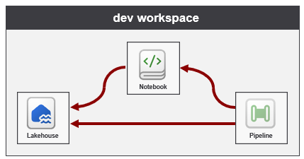
Now think about what happens when you use Fabric GIT synchronization to replicate these three workspace items from the dev workspace to the prod workspace. The outcome you want to avoid is for workspace items created in the prod workspace to retain their dependencies pointing back to an item in the dev workspace. Instead, the desired outcome is for each workspace item to properly resolve its dependencies to its related items in the same workspace. You can see from the following diagram that the notebook and pipeline in the prod workspace were both able to self-manage their relations.
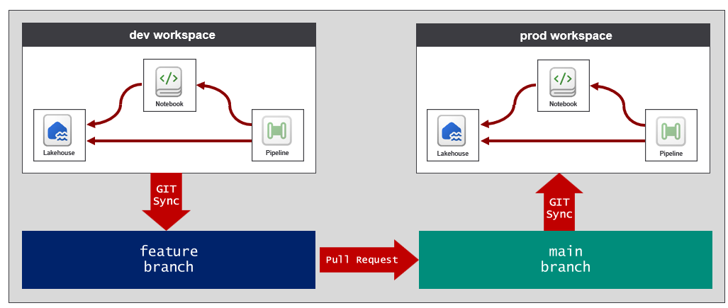
This example demonstrates how notebooks and pipelines support auto-binding behavior. Keep in mind that not all workspace item support auto-binding. If you're building a Fabric solution with workspace item types that lack support for auto-binding, you might be required to write a script for post-sync job to correctly reestablish workspace item relations.
Notebooks did not support auto-binding throughout 2025. However, Microsoft updated the Notebook workspace item type in Q1 of 2026 with support for auto-binding. If you encounter a workspace item type that lacks auto-binding support, it is likely that adding auto-binding support is a work-in-progress that will be released as the workspace item type matures.

Item Definitions
Item definitions represent an essential component type in the Fabric platform's support for CI/CD. At its core, an item definition is a set of files that contain the metadata for an instance of a specific workspace item type. Every item definition requires a file named .platform which is known as the platform file. The platform file contains metadata such as the item type and display name.
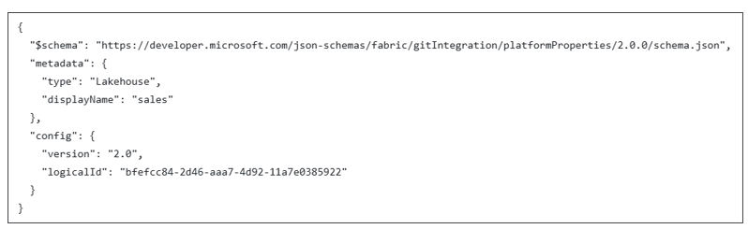
The platform file contains a logicalId value which is used by Fabric internally to track logical instances of workspace items as they are propagated across GIT branches and workspace. For example, what happens when you use GIT synchronization to replicate a lakehouse from the dev workspace to the prod workspace? The two lakehouses have different ids but the same logical id.
In addition to the platform file, each workspace item type defines its own unique schema for the files required and/or allowed in an item definition. For example, the file structure for a notebook item definition is simple. It just requires one additional definition file named notebook-contents.py.
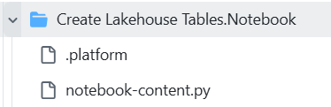
Note that Fabric supports working with Notebook item definitions using either the .py format or the .ipynb format.
The item definition for a lakehouse will contain a different set of item definition files.
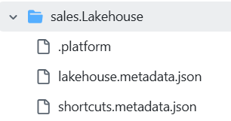
Other workspace item types can have item definitions that are far more complex. For example, the item definition for a semantic model can include dozens or even hundreds of TMDL files.
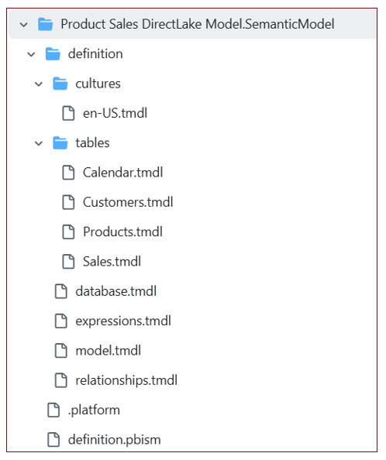
While an item definition with a large number of files is more complicated, it also allow for collaboration in a much more granular fashion. Consider the benefit of splitting out each table into its own file in the item definition for a semantic model. This file structure allows one developer to work on the measures in the Sales table while another developer is making changes to the Calendar table. This extra granularity is essential when multiple developers are working on a large semantic model at the same time.
In general, you should gain a basic understanding of item definition files for the workspace items types you are working with in a Fabric CI/CD project. An easy way to get started is to walk through item definition files created by GIT synchronization.
Fabric Item Definitions
- Item management overview
- Item definition overview
- GIT Repository with public item definition schemas

Automation in Fabric CI/CD
Deploying an end-to-end Fabric solution with CI/CD support requires many steps. The ability to automate the setup process for a Fabric CI/CD project infrastructure is essential. The alternative approach (known as ClickOps) involves completing tasks by hand using a browser in the Fabric service. Relying on ClickOps is not recommended because it can lead to problems caused by human error and unnecessary delays. This is especially true in a scenario involving disaster recovery.
The Fabric platform provides public APIs which make it possible to write and version programming logic that automates all aspects of the Fabric CI/CD setup process. For example, the Fabric REST APIs provides the ability to create workspaces, connections and workspace items. The Azure Microsoft Fabric REST API provides the ability to create and manage Fabric capacities. The Power BI REST API is also important to Fabric developers because it fills some gaps in scenarios in which you need update semantic models and reports.
This section will begin by discussing the common scenarios in which a Fabric CI/CD project requires automation. You will learn what needs to be automated during the setup phase of a project. You will also learn why and when you need to add automation logic into workflows integrated into both the development process and the release process.
Once you understand what you need to automate, you will learn about your options for writing and versioning automation logic. As you will see, you can leverage developer tools that boost your productivity by handling the interaction with Fabric APIs behind the scenes. You will also learn about the alternative approach of writing code that directly calls the Fabric REST APIs. The section will conclude by introducing the fabric-cicd library and explaining how it's used to build a release process.
Microsoft APIs used in Fabric development
- The Fabric REST APIs
- Azure Microsoft Fabric REST APIs
- Power BI REST APIs

Determining What Needs To Be Automated
When starting a Fabric CI/CD project, you need to begin by setting up the project's infrastructure. This is accomplished by creating tenant-level Fabric items such as workspaces, capacities, connections, gateways and deployment pipelines. You also need to create a GIT repository and configure GIT integration support between Fabric workspaces and GIT branches. This is accomplished by creating a GIT source control connection to the repository and then by using that connection to connect one or more workspaces to specific GIT branches.
After a Fabric CI/CD project is up and running, there is often an ongoing need to create and configure feature workspaces. In many scenarios it makes sense to automate the creation of feature workspaces so that you can run an Update from GIT operation immediately followed by programming logic that prepares the workspace for development. For example, the Update from GIT operation will create a lakehouse, but it will not automatically populate the lakehouse with data. The Update from GIT operation will create a semantic model, but it will not automatically create and bind a connection to the semantic model's datasource.
The key observation here is that there is often additional work that needs to be completed after a workspace has been initialized or updated with an Update from GIT operation. This provides a motivation for writing custom scripts to automate whatever tasks are required to prepare the feature workspace for development. As you begin developing these types of scripts, you should consider two different types of jobs.
- Post-deploy jobs run only once after an empty workspace is first initialized with an Update from GIT operation.
- Post-sync jobs run each time after an Update from GIT operation completes on a workspace.
You can think of a post-deploy job as a set of one-time tasks that are part of the workspace initialization process. An example of common tasks automated in a post-deploy job are setting the active value set for a variable library and running a notebook with ETL logic to populate a lakehouse with data. Another common task is preparing a semantic model by creating and binding a connection to its datasource. If you have a semantic model built using import, you should also automate the process of running a refresh operation to ingest and store the imported data.
You should avoid adding ETL logic directly into the scripts that you write for post-deploy jobs. Instead, it's recommended that you factor out ETL logic and add it into workspace items designed for ETL purposes such as notebooks, pipelines, copy jobs, user-defined functions and dataflows. If you write the logic in a post-deploy script to discover a notebook by name and then run it, you can then update the ETL logic in the notebook without requiring any updates to the script.
A post-sync job contains logic that must run every time after an Update from GIT operation completes. One common scenario which requires post-sync logic when is automating a release process using GIT synchronization. Consider a development process like the one shown in the following diagram. Changes to items in the feature workspace are first committed to a feature branch and then merged into the main branch using a pull request.
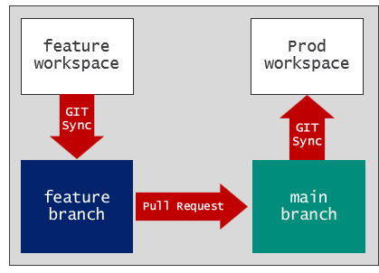
Now it's time to think about the release process. How should you automate synchronizing changes from the main branch to the prod workspace? You can start by creating a workflow that is triggered by a pull request whenever changes are merged to main. This workflow can start by running an Update from GIT operation to sync changes from the main branch to the prod workspace. However, some workspace items might require additional modification after GIT synchronization completes. This can be the case when you are working with workspace items that do not support auto-bind behavior. It can also be the case when you re working with workspace items which require environment-specific settings but do not yet support variable libraries.

Options for Writing Automation Logic
The previous section examined common Fabric CI/CD scenarios in which you are required to write automation logic. You learned about what needs to be automated during project setup and in workflows integrated into the development process and the release process. Now it's time to move ahead and examine your options for writing and maintaining automation logic in a Fabric CI/CD project.
This section begins by introducing two essential developer tools that simplify automation by hiding the low-level details of authenticating and programming against Microsoft APIs. First, you will learn about Terraform and its ability to automate the deployment process which involves creating the infrastructure for a Fabric CI/CD project. After that, you will learn about the Fabric CLI which provides the easiest path to scripting automation logic required in Fabric CI/CD workflows.
The Fabric CLI provides a façade over the Fabric REST APIs to provide an ease-of-use experience at the expense of some degree of control. Experienced developers who prefer control over simplicity have the option of programming directly against the Fabric REST APIs. This section will cover a few essential Fabric REST API topics including how to create and update workspace items using item definitions. You will also learn about the challenges in developing an API-driven release process using Fabric REST APIs followed by a discussion of how the fabric-cicd library assists to overcome thee challenges.
Whether you use a tool such as Terraform or the Fabric CLI or you call Microsoft APIs directly, you must consider the identity used to run your automation logic. Every call to Fabric REST APIs executes under the identity of a specific Entra Id security principal. Fabric REST APIs support two types of identity which are user principals and service principals. It is a best practice to execute API calls as a service principal. This is especially true when code with CI/CD workflow automation logic executes in a cloud-based platform such as Azure pipelines or GitHub Actions workflows.

Creating Project Infrastructure using Terraform
Terraform is an open-source tool built on the principles of infrastructure as code (IaC). IaC is based on the pattern of defining the infrastructure for a software project using configuration files as opposed to using manual processes or procedural programming logic. For most organizations managing cloud based deployments, the use of IaC has become a well-established best practice in DevOps and CI/CD.
When using Terraform, you start by defining a set of resources in one or more configuration files. After that, you can run the Terraform plan command to review a planned lists of the steps required to deploy the configuration. However, running the plan command doesn’t actually do anything. It just shows you the list of steps that need to be completed. When you're ready to deploy, you run the Terraform apply command to run the job that creates the resources needed to match your configuration.
When you first run the apply command to deploy a configuration, Terraform creates a state file which tracks the properties for each resource as it's created or updated. By tracking the state of resources in the current deployment, Terraform can compare what's in your configuration against what's been deployed. This allows Terraform to determine what resources need to be created, updated or destroyed each time you run the apply command.
Terraform is widely adopted because it provides a quick and reliable way to create the required resources during project setup. However, Terraform also plays a valuable role in managing resources over the lifetime of a project. Imagine a scenario in which you need to update a resource after the initial deployment. You just need to update the resource and its properties in your configuration and then run the apply command again.
Terraform simplifies Fabric CI/CD project setup because you only need to define the configuration you want. You don't have to worry about figuring out what steps are required to get there.
Terraform also offers the advantage of building a deployment process that is both versionable and repeatable. For example, you can version a Terraform configuration simply by adding its configuration files to a GIT repository just as you would version any of type of source files. A Terraform deployment process is also repeatable. That means you can run it again and again and it will produce the same outcome. A repeatable process provides consistency and the fastest path to disaster recovery.
From an architectural perspective, Terraform plays the role of an orchestrator which completes its work by calling APIs behind the scenes. But Terraform doesn't call these APIs directly. Instead, it delegates this work to Terraform providers which are plugin components designed to interact with a specific set of cloud-based APIs. One reason that Terraform has become so popular is due to its registry which contains 1000s of available providers allowing you to manage resources in platforms such as Azure, AWS, and Google cloud.
Microsoft released the Fabric provider for Terraform in 2025. Using Terraform together with Fabric provider enables you to deploy Fabric CI/CD project infrastructure by creating and assigning permissions to tenant-level items in Fabric such as workspaces, connections, gateways and deployment pipelines. In addition to Fabric items, a Terraform configuration can also be designed include the provisioning of other types of Azure resources such as an Azure storage account.
Let's look at an example. Image you need to set up a Fabric CI/CD with three environments as shown in the following diagram. In this scenario, each environment requires its own instance of an Azure storge account, a Fabric capacity, a workspace and an ADLS Gen2 connection to the environment's storage account. Automating this type of deployment process using an IoC-based approach is exactly what Terraform was designed for.
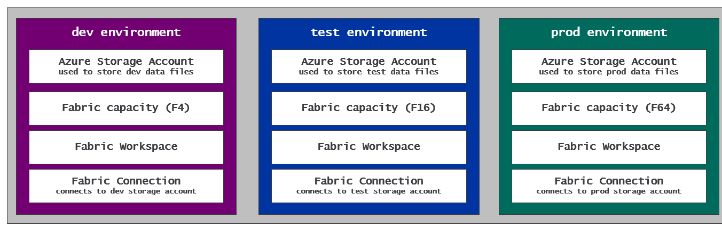
When using Terraform, it is recommended that you create a separate configuration for each environment. After all, you don't want a problem in the configuration of the dev environment or the test environment to affect the prod environment. Fortunately, Terraform makes it possible to define configuration which is reusable across configurations by creating a Terraform module that can serve as a template for provisioning a consistent set of resources across multiple environments.
Let's walk through a simple example. You can start by creating a Terraform module with a reusable configuration designed to provision a standard set of resources including a storge account, a capacity, a workspace and a connection. After that, you can reference that module in the three configurations you create for the dev, test and prod environments.
By parameterizing your Terraform module with input variables, you can configure the deployment process to create the resources for each environment with unique property settings for things like display names and the SKU size of the Fabric capacity. For example, you can provision the capacities for your project with an F4 for dev, an F16 for test and F64 for prod.
Now think about the scenario a few months later when you determine the test environment capacity isn't as powerful as it needs to be and you need to dump it up to a larger SKU size such as F32 or F64. This example demonstrates how Terraform can make life easier. You just need to update the test environment configuration with the new SKU size value and run the apply command. That's it. Now your problem is figuring out what to with the all free time you're afforded since adopting Terraform.
The walkthrough in Part 2 - Deploying a Fabric CI/CD Project will demonstrate the technique of creating a Terraform module as an environment template for use across three configurations to create environments for dev, test and prod.
Resources for Terraform
- Terraform Documentation
- Terraform on Azure documentation
- Microsoft Fabric Provider
Terraform and the Fabric provider also provide capability to create workspace items such as lakehouses and notebooks. However, you will find that working with item definitions in a Terraform configuration is tricky because making dynamic updates to item definition files requires advanced Terraform templating syntax. Many experienced Fabric CI/CD practitioners prefer using Terraform exclusively for creating and managing tenant-level items in Fabric while using either Fabric CLI or programming the Fabric REST APIs methods for creating and managing workspace items.

Automation using the Fabric CLI
Fabric CLI is a developer tool that offers the easiest path to writing automation logic to complete tasks in Fabric for DevOps and CI/CD. At a high level, Fabric CLI acts as a façade which abstract away the underlying Microsoft APIs to provide a single, focused experience to assist with Fabric automation. Fabric CLI adds value by shielding you from having to worry about Entra Id authentication, access token acquisition and the execution of HTTP requests. Fabric CLI also simplifies running automation logic under the identity of a service principal.
Fabric CLI is a is a command-line interface tool that supports both an interactive mode and a scripting mode. The interactive mode allows you to type and execute a sequence of commands. For example, you can use Fabric CLI in interactive mode to quickly create a new workspace and then to create a lakehouse inside that workspace. Fabric CLI also provides commands to load data into lakehouse tables and to automate running notebooks and pipelines which contain ETL logic.
Fabric CLI scripting mode makes it possible to write and version automation logic for a Fabric CI/CD project. For example, you can use a shell script or a programming language such as PowerShell or Python to execute a sequence of Fabric CLI command. If you decide not to use Terraform, you can write scripts which call Fabric CLI commands to create and manage tenant-level items such as workspaces, capacities, connections, domains and gateways.
Fabric CLI offers rich support for creating and managing workspace items. For example, Fabric CLI provides commands such as create, get, set and rm to perform CRUD operations on workspace items. There are also two Fabric CLI commands that allow you to work with an item definition. Fabric CLI provides an import command used to create or update an workspace item using an item definition. There is also a complimentary export command used to export a workspace item to an item definition as a set of definition files in a local folder.
Links for more information about Fabric CLI
- Fabric CLI
- CLI Modes
- Fabric CLI Commands
- Fabric CLI Usage Examples
Another important capability of Fabric CLI is its ability to integrate with cloud-based GIT providers such as Azure DevOps and GitHub. If you're developing workflows using Azure pipelines or GitHub workflow actions, it's relatively straight forward to install and load Fabric CLI executable which enables you develop workflows with logic written to call Fabric CLI commands.

Programming the Fabric REST APIs
Developer tools like Terraform and Fabric CLI boost your productivity by hiding low-level details associated with authentication, acquiring access tokens and executing HTTP requests. However, you might encounter scenarios in which you need a greater degree of control. This can be achieved by programming the Fabric REST API to execute API calls using a familiar programming language such as Python, C# or PowerShell. For developers already experienced in calling REST APIs, programming the Fabric REST API might provide a more natural fit than using developer tools such as Terraform or Fabric CLI.
You have learned that Terraform is recommended for creating infrastructure in larger Fabric CI/CD projects. But there could be factors that make you decide against using Terraform in a particular Fabric CI/CD project. As an alternative, you can write automation scripts which call the Fabric REST APIs to create tenant-level Fabric items such as workspaces, connections, gateways and deployment pipelines. Using Fabric REST APIs also makes it possible to fully automate the process setting up GIT integration for a Fabric CI/CD project. This is achieved by creating a GIT source control connection and then using that connection to bind workspaces to GIT repository branches.
Programming the Fabric REST APIs provides the richest support for managing the lifecycle of workspace items. This is due to the ability to work directly with items definitions when calling CRUD APIs to create and update workspace items. This makes it possible to deploy a Fabric solution to a target workspace using a repeatable process which ensure workspace items are created with the correct relationships to other workspace items in the same workspace. For example, you can create a lakehouse and a notebook in such as way that the notebook is configured to use the new lakehouse as its default lakehouse.
The Fabric REST APIs can be used to control GIT synchronization. There is an Update From Git API which can be used to initialize or update a feature workspace from an underlying GIT branch. It's also common to call Update From Git in a release process workflow to synchronize changes from GIT branch to workspace items. There is a complimentary Commit To Git API used in scenarios in which you need to automate the commit operation to push workspace item changes to a GIT branch.
If you decide to program directly against the Fabric REST APIs, there are a few fundamental you need to learn right away. The Fabric REST APIs are built upon three essential concepts which are paginated results, long-running operations (LRO) and throttling. Developers who choose to program the Fabric REST APIs must understand these concepts in order to write code that is correct and reliable. Fortunately, this is something you don't have to worry about when using developer tools such as Terraform and Fabric CLI which deal with paginated results, long-running operations and throttling behind the scenes.
Fabric REST API Fundamentals
- Pagination
- Long running operations
- Throttling
Microsoft offers two Software Development Kits (SDKs) for the Fabric REST APIs. Microsoft provides a Microsoft Fabric .NET SDK for C# developers and a Microsoft Fabric Python SDK for Python developers. These SDKs provide a productivity boost by hiding low-level details of executing HTTP requests, transmitting access tokens and converting back and forth between JSON and strongly-typed objects. The two SDKs also provide the convenience of dealing with paginated results, long running operations and throttling errors behind the scenes.
Unlike the Fabric CLI and Terraform, the Fabric REST APIs SDK do not provide the convenience of authenticating or acquiring access tokens for you. Regardless of whether you using Fabric REST APIs SDK or calling Fabric REST API endpoint directly, you need custom code to authenticate with Entra Id and to acquire access token. The best practice for writing this type of code is to use the Microsoft Authentication Library (MSAL) which offers versions for several platforms and programming languages.
Fabric REST API SDKs
- Microsoft Fabric .NET SDK
- Python SDK (coming soon)
Let's examine a scenario in which you might prefer programming the Fabric REST APIs as an alternative to using Fabric CLI. Imagine you need to deploy a Fabric solution to a target workspace which involves creating a lakehouse and a notebook. You have an existing item definition for a notebook containing Python code with the ETL logic needed to populate the lakehouse with data. As a requirement, you need to create the notebook in such a way that it references the new lakehouse as its default lakehouse. This means you need to update the item definition file named notebook-contents.py with the lakehouse id before you can use the item definition to create the notebook.
There is a timing issue involved in this scenario. You cannot determine the new lakehouse Id until after the lakehouse has been created. Once the lakehouse has been created, you must then update the item definition file notebook-contents.py with the Id of the new lakehouse. This might lead you to automate your deployment process with Fabric CLI using the following steps.
- Run a script which calls the Fabric CLI import command to create the lakehouse
- Examine new lakehouse in the Fabric service using a browser to discover its Id
- Open notebook-contents.py in a text editor and update the metadata which references the default lakehouse
- Save your changes to notebook-contents.py
- Run a script which calls the Fabric CLI import command passing the updated item definition to create the notebook
The problem here is that the Fabric CLI import command depends on files persisted in the item definition folder. The import command provides no ability to modify an item definition on the fly. Instead, you must make changes to an item definition file and save your changes before calling import.
There's a more flexible approach available if you're willing to program using the Fabric REST APIs or one of its available SDKs. More specifically, you can load a item definition into memory and update it dynamically on the fly before calling Create Item or Update Item Definition. The ability to dynamically update an item definition file provides a more seamless experience when developing a Fabric solution where you're required to create a set of workspace items with dependencies between them.
The Fabric REST APIs offer three primary APIs which involve programming with item definitions. First, the Create Item API allows you to pass an item definition when creating a workspace item. Second, the Update Item Definition API allows you to pass an item definition when updating a workspace item. Third, the Get Item Definition API allows you to retrieve the item definition for an existing workspace item.
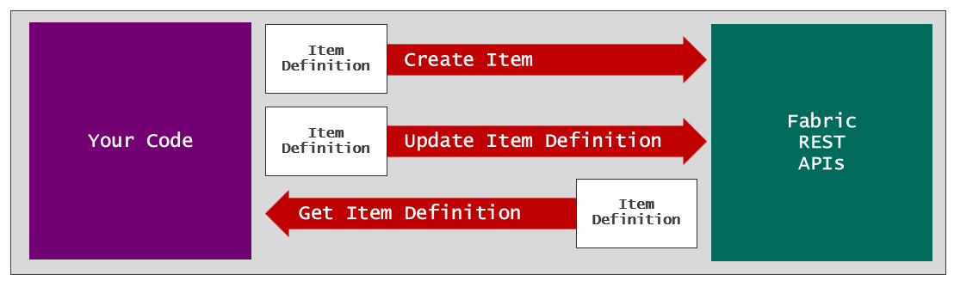
Let's walk through a scenario in which creating a workspace item requires dynamically updating an item definition file. Imagine you have just used the Fabric REST API to create a workspace and a lakehouse inside that workspace. Now it's time to create the notebook. However, you have to create a notebook in such a way that it's configured to use the lakehouse as its default lakehouse.
As discussed earlier, the item definition file notebook-content.py used to create a notebook contains metadata which tracks the configuration of its default lakehouse. The metadata is hidden from users when the notebook is opened in the web-based notebook editor provided by the Fabric service. However, you can view this metadata by examining the raw file contents of notebook-content.py file as shown in the following screenshot.
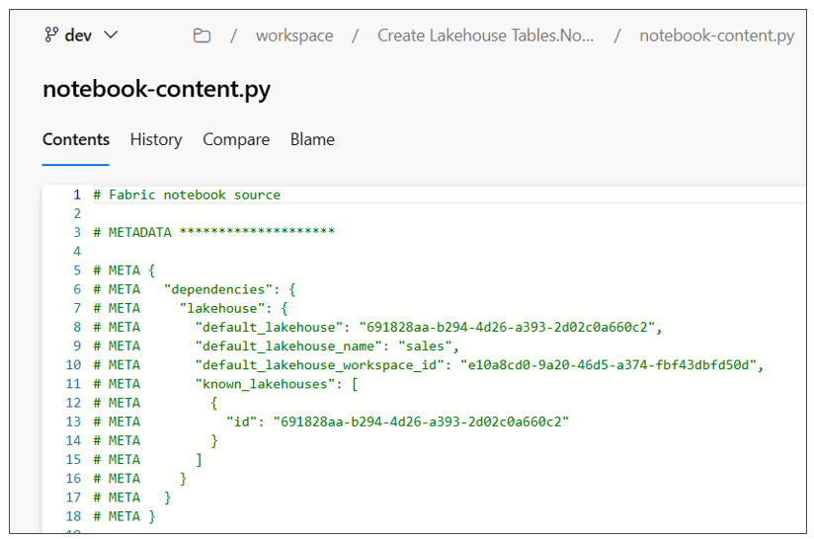
Before calling Create Item, you first need to update the contents of notebook-content to include the correct workspace id and lakehouse id. This means your code must track the ids of the workspace and the lakehouse as they are created. Once you have determined what the ids are, you can perform some type of find-and-replace operation to substitute the workspace id, lakehouse id and lakehouse display name into the contents of notebook-content.py.
# Fabric notebook source

# METADATA ********************

# META {
# META "dependencies": {
# META "lakehouse": {
# META "default_lakehouse": "{LAKEHOUSE_ID}",
# META "default_lakehouse_name": "{LAKEHOUSE_NAME}",
# META "default_lakehouse_workspace_id": "{WORKSPACE_ID}",
# META "known_lakehouses": [
# META {
# META "id": "{LAKEHOUSE_ID}"
# META }
# META ]
# META }
# META }
# META }
Directly manipulating item definition files is a powerful technique that assumes you know what you are doing. If you update an item definition file with invalid syntax, you will experience errors when calling Create Item and Update Item Definition.
Now let's walk through the programming steps required to call Create Item using an item definition. First, you need to enumerate through all the files in the item definition folder and load their contents and their relative files paths into memory. At this point you can updated the contents of notebook-content.py in memory with the metadata for the default lakehouse.
The next step is to parse together a JSON payload that allows you to pass the item definition across the network. Things get a bit tricky because there's a need to pass the contents of multiple files across the network in a single HTTP request. The way to accomplish this is to convert the contents of each file into a base64 encoded format. By formatting file contents using base64 encoding, you can add the content of any file into a JSON element as a standard string value. This makes it possible to transmit all the files required for an item definition across the network in a call the Create Item API.
The following JSON listing shows an example of an HTTP request body that can be passed across the network in a call to the Create Item API. The definition element contains a parts collection which contains a part element for each file in the item definition. Each part element includes a relative path value and a payload for the file contents in a base64 encoded format.
{
"displayName": "Create Lakehouse Tables",
"type": "Notebook",
"definition": {
"parts": [
{
"path": ".platform",
"payload": "********************BASE64-ENCODED-FILE-CONTENT********************"
"payloadType": "InlineBase64"
},
{
"path": "notebook-content.py",
"payload": "********************BASE64-ENCODED-FILE-CONTENT********************"
"payloadType": "InlineBase64"
}
]
}
}
At this point, you should be able to make an observation about the difference between using Fabric CLI compared to programming the Fabric REST APIs. Programming the Fabric REST APIs provides more control but at the expense of significantly more complexity. When you use the Fabric CLI import command, all the work of formatting file contents back and forth between base64 encoding and clear text is handled for you behind the scenes. Fabric CLI doesn't provide as much control, but it sure makes things a lot easier.
Consider another convenience provided by the Fabric CLI import command. You don't have to worry about whether the target workspace item already exists or not. Fabric CLI has a way to determine whether the item already exists. If the item does not exist, the call to import command results in an API call to Create Item. If the item does exist, Fabric CLI calls Update Item Definition instead. To implement the same logic with the Fabric REST APIs requires multiple steps. First, you need to call an API such as Get Items to determine whether the target item exists. You must follow that with conditional logic which determines whether to call either Create Item or Update Item Definition.
Let's examine another common scenario in which you need to program the Fabric REST APIs to update an existing workspace item. Perhaps you'd like to update the metadata for an existing notebook to switch its default lakehouse from one lakehouse to another. You can accomplish this using the following steps.
- Call Get Item Definition to retrieve JSON response with the current item definition
- Extract the notebook-content.py file content and convert it from base64 to plain text
- Perform a find-and-replace operation on notebook-content.py to update the workspace id and lakehouse id
- Convert the updated file contents for notebook-content.py back into the base64 encoded format
- Update the JSON element for the item definition with the base64 encoded content for notebook-content.py.
- Call Update Item Definition passing the JSON with the updated item definition.
This section examined programming the Fabric REST APIs using item definitions to create and update workspace items. When you compare this approach to using the Fabric CLI import command, there is more control yet also a greater level of complexity. You have to decide which approach is best for you. If you have seen the movie The Matix, you can make the analogy that the Fabric CLI represent the blue pill while Fabric REST API programming represents the red pill.
Resources for working with item definitions
- Fabric item definitions overview
- Create Item API
- Get Item Definition API
- Update Item Definition API
When you begin to program the Fabric REST APIs, you might notice that it provides item-generic APIs as well as item-specific APIs. You've already seen examples of using item-generic APIs such as Create Item and Update Item Definition. However, the Fabric REST APIs also offer item-specific APIs such as Create Lakehouse and Create Notebook. This begs the question should you use item-generic APIs or item-specific APIs.
With respect to creating, updating and deleting workspace items, it doesn’t really matter whether you use the item-generic APIs or item-specific APIs because the result will be the same. For this reason, many developers prefer using item-generic APIs to create and update workspace items because it allows them to write generic code which can be reused with any type of workspace item.
The only time where it's essential to use item-specific APIs is when you need to a query a workspace item to retrieve its properties. As an experiment, let's compare the results of calling Get Item versus Get Lakehouse. A call to Get Item results in an HTTP GET request to a URL which targets the items endpoint for a specific workspace.
https://api.fabric.microsoft.com/v1/workspaces/{workspaceId}/items/{itemId}
The response from Get Item returns a JSON element which contains properties common to all types of workspace items.
{
"displayName": "sales",
"description": "Contain for sales data",
"type": "Lakehouse",
"workspaceId": "{LAKEHOUSE_ID}",
"id": "{WORKSPACE_ID}"
}
Now let's compare this to a call to Get Lakehouse which uses an URL targeting the lakehouses endpoint for a workspace.
https://api.fabric.microsoft.com/v1/workspaces/{workspaceId}/lakehouses/{lakehouseId}
The response from Get Lakehouse includes a properties element with additional properties that are specific to lakehouses.
{
"displayName": "sales",
"description": "Contain for sales data",
"type": "Lakehouse",
"workspaceId": "{LAKEHOUSE_ID}",
"id": "{WORKSPACE_ID}"
"properties": {
"oneLakeTablesPath": "https://onelake.dfs.fabric.microsoft.com/{workspaceId}-{ItemId}/Tables",
"oneLakeFilesPath": "https://onelake.dfs.fabric.microsoft.com/{workspaceId}-{ItemId}/Files",
"sqlEndpointProperties": {
"connectionString": "{SQL_ENDPOINT_UNIQUE_PATH}.datawarehouse.fabric.microsoft.com",
"id": "{SQL_ENDPOINT_ID}",
"provisioningStatus": "Success"
}
}
}
There is a common scenario in which you need to create a lakehouse along with a semantic model which connects to that lakehouse using the OneLake URL or the SQL endpoint. After creating the lakehouse, you need to call the Get Lakehouse API to discover its properties so that you can update the semantic model with the correct connection settings.

Building a Release Process
Now it's time to revisit the topic of building a release process for a Fabric CI/CD project. Earlier you learned that Deployment Pipelines provide a low-code approach for building a release process. However, Deployment Pipelines have limitations which limits their use in certain scenarios. For example, a Deployment Pipeline and all of its associated workspaces must exist inside the same Entra Id tenant. If you have a requirement create the dev workspace in one Entra Id tenant and the prod workspace in another, you must choose a different approach for building your release process.
A second option for building a release process in Fabric is using GIT synchronization. When using this approach, you can call the Update from GIT API to push changes from a release branch to workspace items in a target workspace. However, there are issues to consider when deciding whether to build a release process based on Fabric GIT synchronization.
First, there is typically extra work required after a call Update from GIT completes. For example, you might be required to write code for a post-sync job to update workspace items to reestablish item relations or to replace environment-specific settings.
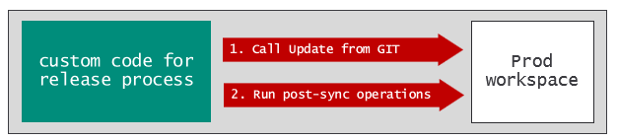
A second issue with using GIT synchronization is that requires a connection between the target workspace and a GIT branch. When a workspace is connected to a GIT branch, the Fabric service lights up the workspace with indicators and messages to control and monitor GIT synchronization. For example, the workspace summary page displays the Status column with values such as Synced or Update required which you might prefer to hide from users in a production workspace.
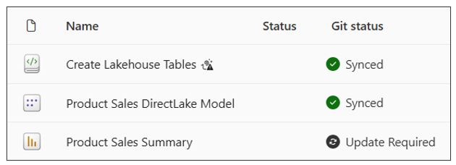
The third option for building a release process is use Fabric REST APIs to automate pushing changes from GIT to a target workspace. Implementing a release process using an API-driven approach has become popular because it's able to address and overcome the limitations and issues involved with using Deployment Pipelines or GIT synchronization.
The goal of an API-driven release process is to update the items in a target workspace using item definitions retrieved from a GIT branch. The release process must contain logic to determine if target items already exist so it can decide whether to call Create Item or Update Item Definition. The release process should also be designed with the ability to update item definitions on the fly to replace environment-specific settings and to reestablish relationships between workspace items
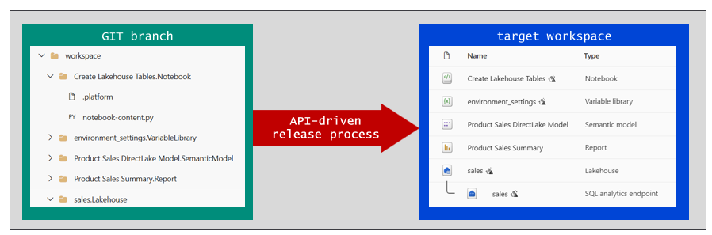
In theory, you could spend the time and energy required to implement a release process using the Fabric REST APIs. However, this approach would require a non-trivial coding effort because it requires custom logic that differs across workspace item types. Fortunately, there's a much better option. You can fully implement your release process without incurring significant technical debt by leveraging the fabric-cicd library.

The fabric-cicd Python Library
fabric-cicd is an open-source Python library designed by Microsoft to enable a code-first approach for deploying and updating Fabric solutions. Code-first deployment in Fabric is based on a development methodology in which you begin by creating a set of item definitions. After that, you use these item definitions as templates to deploy workspace items to a target workspace.
If you have a folder in GIT containing item definitions, fabric-cicd provides an easy way to deploy your code to a target workspace. Behind the scenes, fabric-cicd handles authentication with Entra Id as well as all the required interaction with Fabric REST APIs. By acting as a façade, the fabric-cicd library provides a significant productivity boost by hiding all the grungy details involved with Fabric REST API programming and performing dynamic updates on item definition files.
While the fabric-cicd library is an open source project, it is officially supported by the Fabric product team. You can have confidence that fabric-cicd will continue to evolve by adding support for new workspace item types add to the platform.
The fabric-cicd library is available in the Python Package Index (PyPI) which enables you to install it using pip install.
pip install fabric-cicd
The fabric-cicd library is commonly used to build release processes that run in Azure DevOps or in GitHub. The ability to install on demand using pip install makes it easy to integrate fabric-cicd with Azure pipelines or GitHub Custom Actions.
To get started with fabric-cicd, you first need to create a FabricWorkspace object initialized with the three properties.
- repository_directory: path to top-level folder which contains item definitions
- workspace_id: target workspace id
- item_type_in_scope: string array containing workspace item types to include in deployment processing
After initializing a FabricWorkspace object, you can pass it as a parameter in a call to a function named publish_all_items. The call to publish_all_items starts the fabric-cicd deployment process and blocks synchronously until the job completes.
from fabric_cicd import FabricWorkspace, publish_all_items

# Initialize the FabricWorkspace object with the required properties
target_workspace = FabricWorkspace(
repository_directory = "{PATH_TO_ FOLDER_WITH_ITEM_DEFINITIONS}",
workspace_id = "{TARGET_WORKSPACE_ID}",
environment = "PROD",
item_type_in_scope = ["Lakehouse", "Notebook", "SementicModel", "Report", "VariableLibrary"],
)

# run the deployment process
publish_all_items(target_workspace)
When you call publish_all_items, fabric-cicd runs a deployment process which enumerates through each item definition and calls either Create Item or Update Item Definition depending on whether the target item already exists. Keep in mind that fabric-cicd will ignore any workspace items whose type is not explicitly included in the item_type_in_scope property.
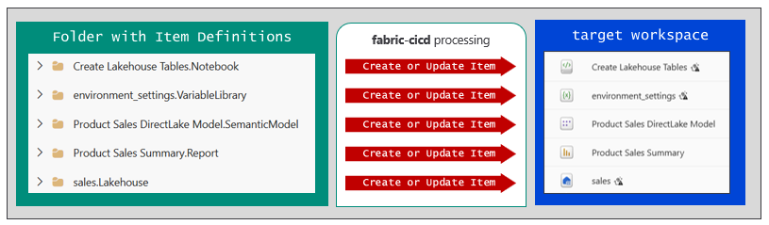
You've just learned how to use fabric-cicd to push changes from a source folder of item definitions to a target workspace. The next thing you need to learn is how to dynamically modify item definition files as part of the fabric-cicd deployment process. This is accomplished by leveraging fabric-cicd support for parameterizing environment-specific settings.
Before walking through how to set up parameterization, let's first discuss when it's necessary. Imagine you're working with a Fabric solution designed with a lakehouse and a semantic model. The semantic model connects to the lakehouse as its datasource using a DirectLake on OneLake connection. You are currently at a phase where you have this Fabric solution up and running in the dev workspace.
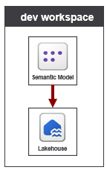
Your next step is to set up GIT integration between the dev workspace and a release branch. You connect the dev workspace to the release branch and run a Commit to GIT operation to persist item definitions to GIT. The thing to focus on in this example is the semantic model definition in GIT which has a datasource setting which points to the lakehouse in dev. The problem you need to avoid is propagating these types of environment-specific settings from dev to prod.
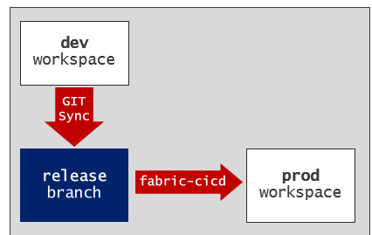
Think about what happens when you deploy the lakehouse and semantic model from the release branch to the prod workspace. Without parametrization, your deployment will be flawed because the semantic model in prod will be configured to connect to the lakehouse in dev. The motivation for using parameterization is that you can dynamically update the item definition for the semantic model before its used to create or update the target semantic model item in prod. By using parameterization, you can deploy a semantic model with datasource settings to successfully reference the lakehouse in prod.
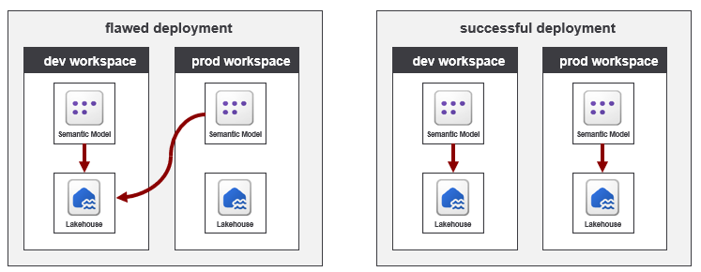
In general, parameterization is required whenever you need to deal with environment-specific settings committed to GIT.
Now it's time to discuss how to enable parametrization with fabric-cicd. It requires two steps. The first step is to add a parameter file. The second step is to initialize the FabricWorkspace object the environment property. Let's start by adding a parameter file named parameter.yml which is located in the root folder containing the item definitions.
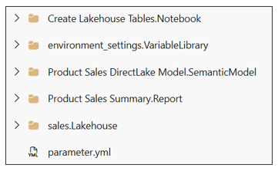
To address the deployment problem with the semantic model, you must configure parameter.yml to run a find-and-replace operation to redirect the semantic model's datasource from the lakehouse in dev to the lakehouse in the target workspace.
The following YAML listing demonstrates the configuration required to run a find-and-replace operation. There is a top-level key named find_replace with nested keys named file_value and replace_value. The find_value key is assigned a string value with the datasource path from the dev workspace that you want to replace. The replace_value key contains a nested key-value pair for each target environment. In this example, the configuration defines two target environments named TEST and PROD.
find_replace:

- find_value: "https://onelake.dfs.fabric.microsoft.com/{dev-workspace-id}-{dev-lakehouse-id}" # [dev]
replace_value:
TEST: "https://onelake.dfs.fabric.microsoft.com/{test-workspace-id}-{test-lakehouse-id}" # [test]
PROD: "https://onelake.dfs.fabric.microsoft.com/{prod-workspace-id}-{prod-lakehouse-id}" # [prod]
By default, fabric-cicd processes a find-and-replace operation by inspecting every file in each item definition who type is include in the item_type_in_scope property setting. This can lead to longer processing times in scenarios in which you have a large number of items or you have item definitions with a large number files.
To optimize performance, fabric-cicd parameterization allows you to define filters to control which items and files are examined during a replacement operation. For example, you can extend the find_value key by adding filtering keys such as item_type, item_name and file_path. The following configuration demonstrates how to filter a find-and-replace operation to restrict processing so it only inspects the expressions.tmdl file found in the item definitions for semantic models.
find_replace:

- find_value: "https://onelake.dfs.fabric.microsoft.com/{dev-workspace-id}-{dev-lakehouse-id}" # [dev]
replace_value:
TEST: "https://onelake.dfs.fabric.microsoft.com/{test-workspace-id}-{test-lakehouse-id}" # [test]
PROD: "https://onelake.dfs.fabric.microsoft.com/{prod-workspace-id}-{prod-lakehouse-id} # [prod]
Item_type: "SemanticModel"
file_path:
- "/definition/expressions.tmdl"
The second step required to get parameterization working is to initialize the FabricWorkspace object with one additional property named environment. By specifying a value for environment, you are able to select which set of environment settings you'd like to use for the current deployment. Once you have configured parameter.yml with target environments such as TEST and PROD, it's trivial to write the code to deploy to either the test workspace or the prod workspace
test_workspace = FabricWorkspace(
environment = "TEST",
repository_directory = "{PATH_TO_FOLDER_WITH_ITEM_DEFINITION}",
workspace_id = "{TEST_WORKSPACE_ID}",
item_type_in_scope = ["Lakehouse", "Notebook", "SementicModel", "Report", "VariableLibrary"]
)

publish_all_items(test_workspace)

prod_workspace = FabricWorkspace(
environment = "PROD",
repository_directory = "{PATH_TO_FOLDER_WITH_ITEM_DEFINITION}",
workspace_id = "{PROD_WORKSPACE_ID}",
item_type_in_scope = ["Lakehouse", "Notebook", "SementicModel", "Report", "VariableLibrary"]
)

publish_all_items(prod_workspace)
The parameterization support in fabric-cicd is powerful because it allows you to build a release process with a one-to-many mapping between a single release branch and multiple target workspaces. This flexibility provides another reason why you might select fabric-cicd over Deployment Pipelines and GIT synchronization as the best choice for building a release process.
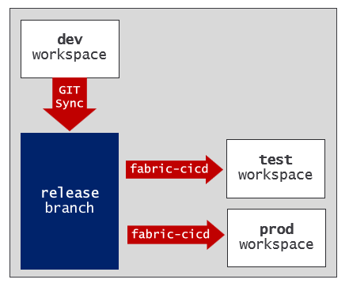
The rich parameterization support available with fabric-cicd goes far beyond what you saw in this simple example. There is support for configuring replacement operations which use regular expressions and which use key-based lookups to modify the contents of JSON files and YAML files. There is also parameterization support for setting the Spark settings in the target workspace and for binding a semantic model to a pre-existing connection.
Resource for learning more about fabric-cicd
- Home page
- Code Samples
- Code Reference
- Parameterization

Developing Workflows for a Fabric CI/CD Project
Now that you've seen your options for how to write the code to implement Fabric CI/CD tasks, the next question is where to deploy that code. The answer to this question is simple. You want to deploy and run your code in the same GIT repository that holds the item definitions. The next two sections will introduce the topic of hosting custom code in Azure DevOps and GitHub.

Developing Azure Pipelines
Azure DevOps is a Microsoft cloud platform that provides a suite of development tools for software teams to plan, build, test, and deploy applications. It's designed with CI/CD features to support the entire software development lifecycle. When you create a new project in Azure DevOps, the project is automatically created with a GIT repository of the same name. For example, creating a project named Project1 will automatically create a repository named Project1. In many scenarios, the GIT repository that's created along with the project is all you need. However, you can always add other repositories to a project if it's needed.
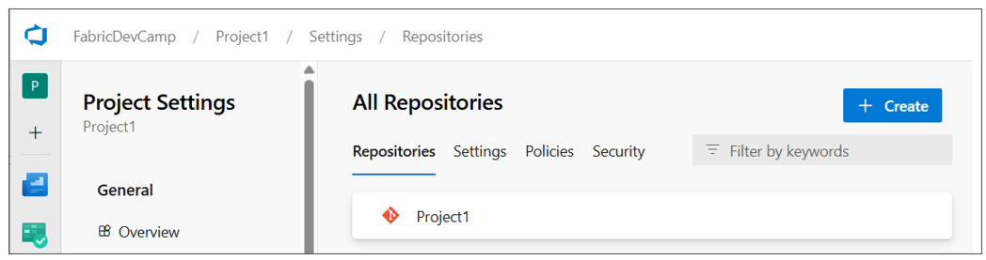
Azure Pipelines is the CI/CD workflow service that's built into Azure DevOps which provides features to integrate, test and deploy code using the principals of CI/CD. An Azure pipeline can be configured to run on-demand or on a schedule such as every night at midnight. Alternately, you can define an Azure pipeline with a trigger to run automatically in response to a code commit or the completion of a pull request.
To create an Azure pipeline, you must first add a YAML file into your repository. Once you have added the YAML file, you must then explicitly register it with the Azure DevOps project. This can be accomplished through the Azure DevOps user interface or it can be automated using the Azure DevOps CLI or the Azure REST APIs. Once a pipeline has been registered, you should be able to see it in the Pipelines page in an Azure DevOps project.
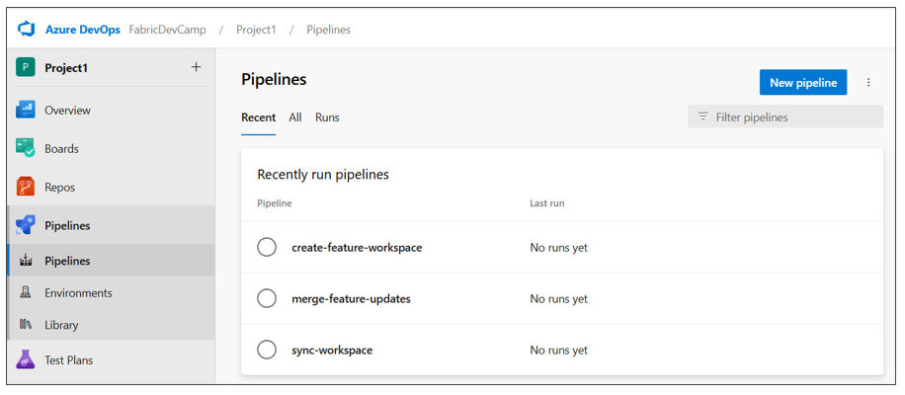
You can write the code for an Azure pipeline in a programming language such as PowerShell or Python. This is accomplished by referencing the script with the PowerShell or Python code from the YAML file. The following screenshot shows an example of three YAML files for three Azure pipelines in the .pipelines folder and their associated Python scripts in the src folder. Below these two folders you can also see the workspace folder which contains the item definitions for a specific workspace.
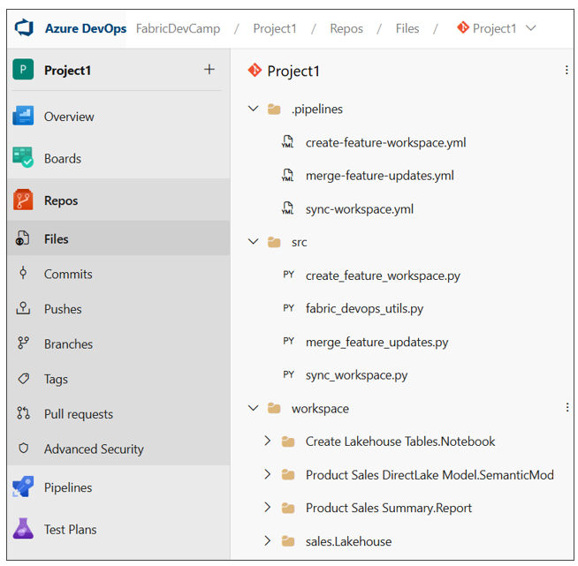
As you begin to develop Azure pipelines for a Fabric CI/CD project, you will find there's a need to track environment settings such as the ids for workspaces, capacities, users and groups. You might also need authentication credentials for an Entra Id application so your code can authenticate as a service principal. The Azure pipelines service allows you to create variables to track these types of environment settings.
In order to create variables for use in Azure pipelines, you must first create a variable group. Once you have created a variable group, you can then add a set of named variables along with their values. The following screenshot shows the typical set of variables created for Azure pipelines in a Fabric CI/CD project.
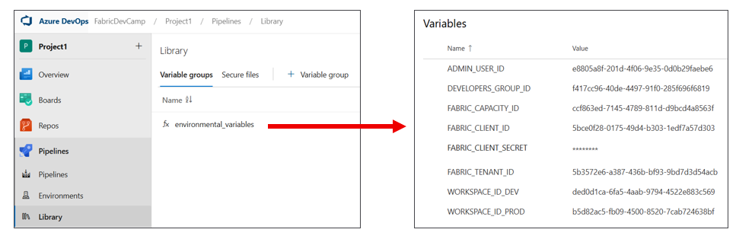
When you create a variable that contains sensitive data, you can mark that variable as a secret. For example, your pipeline might need to access to a client secret used to authenticate as a service principal. When you mark a variable as a secret, the Azure DevOps service does several important things to protect its value. First, the variable is persisted in the cloud using an encrypted format rather than plain text. Second, the value cannot be viewed in the Azure DevOps user interface after saving. Third, the secret value is masked in logs. If the secret value appears in pipeline output, Azure Pipelines replaces it with *** so it won't be visible in build logs.
Variable groups in Azure DevOps can also be integrated Azure Key Vault. That means you can configure access to secrets in Azure Key Vault from code running in an Azure pipeline. This makes it possible to benefit from Azure Key Vault features such as conditional access policies, auditing, and secret rotation.
By default, an Azure pipeline does not have access to the variables in a variable group. Instead, you must configure permissions for a variable group to ensure the code in your Azure pipelines has access to its variables and secrets. These permissions can be configured using the Pipeline permissions dialog in the Azure Devops user interface or by using the Azure DevOps CLI or the Azure REST APIs.
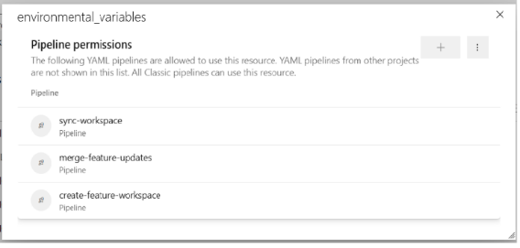
As you begin to develop with Azure pipelines, you should become familiar with monitoring pipeline runs in order to test and debug your code. It's important to add logging to your code to report on successful operations and to provide diagnostic information about any errors that occur. The following screenshot shows how an Azure pipeline can be written to log its progress in a Fabric CI/CD workflow.
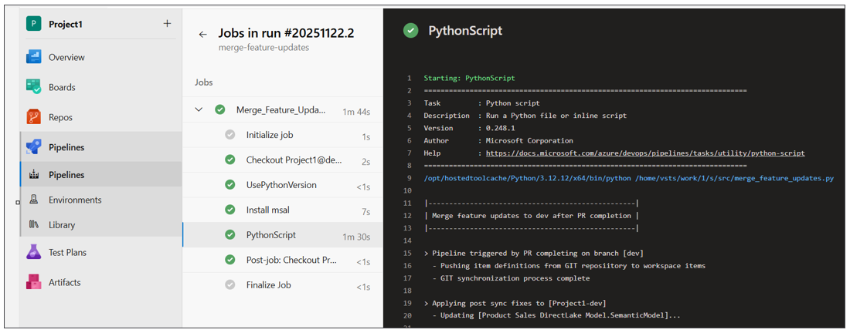
Azure DevOps Pipeline Resources
- Azure Pipelines documentation
- Key concepts
- YAML pipeline editor
- Manage variable groups
- Use Azure Key Vault secrets in Azure Pipelines

Developing GitHub Workflow Actions
GitHub is different from Azure DevOps with respect to how you work with projects and repositories. GitHub allows you to create repositories without first creating a project. While GitHub supports creating projects to assist with organizing repositories, the use of projects in GitHub is optional. When using GitHub as the GIT provider for a Fabric CI/CD project, you just need to create a repository to get started.
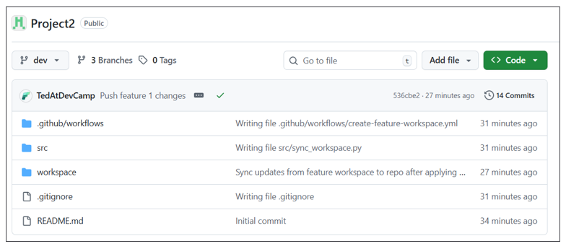
GitHub Actions is the workflow platform in GitHub that allows you to automate CI/CD tasks. You can create GitHub Actions workflows that can be run on-demand or run on a schedule. You can also configure workflows to run in response to events such as a code commit or the completion of a pull request.
With GitHub Actions, you create a new workflow by copying a YAML file into a special repository folder named .github/workflows. Unlike Azure pipelines, there is no need to register the YAML file with GitHub. Just coping to YAML file into the .github/workflows folder is all you need to do. Inside the YAML file, you can reference a script written in a language such as PowerShell or Python. The following screenshot shows a typical example of the file structure of a Fabric CI/CD project in a GitHub repository.
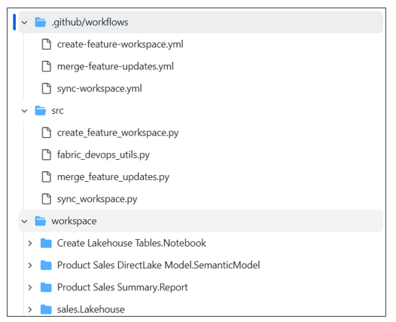
As you begin to develop Git Actions workflows for a Fabric CI/CD project, you need a way to track environment settings such as the ids for workspaces, capacities, users and groups. Your code might also need authentication credentials to authenticate as a service principal. GitHub allows you to create secrets and variables to track these types of environment settings.
You can create secrets in a GitHub repository by navigating to Settings and selecting the Secrets and variables > Actions. When you create a secret, GitHub will encrypt its value and redact it from logs. A GitHub Actions workflow decrypts a secret at runtime, injects it into your workflow and then immediately discards it from memory when the workflow completes.
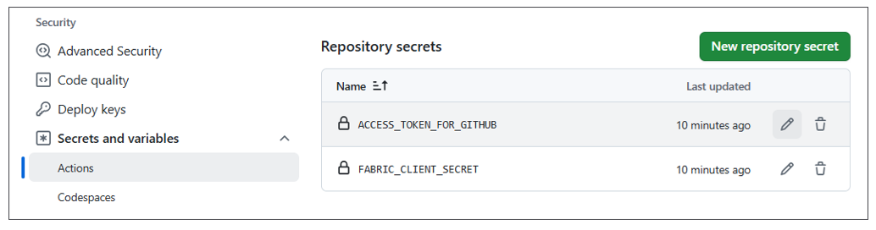
You can also add variables to a GitHub repository for environment settings that are not sensitive. The following screenshot shows an example of variables created for Azure pipelines in a Fabric CI/CD project.
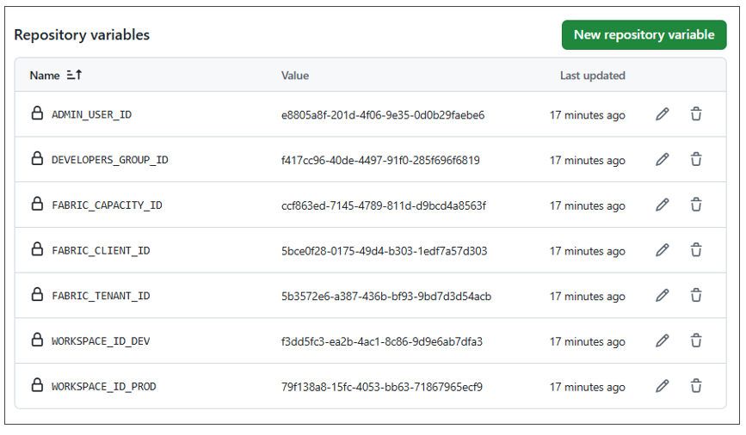
Unlike Azure pipelines, there is no need to configure permissions because GitHub Actions workflows automatically have access to secrets and variables in the same repository by default.
While creating secrets and variables at the repository level is adequate for some projects, you might find you need more granularity. GitHub supports a feature which allows you to create environments in a GitHub repository and then to create secrets and variables at environment scope.
Consider a CD release process in which workspaces don't exists within the same Entra Id tenant. For example, imagine the dev workspace, the test workspace and the prod workspace all exist in different Entra Id tenants. In this scenario, you will need different authentication credentials for each Entra Id tenant. You can start by creating three different environments in your GitHub repository named dev, test and prod.
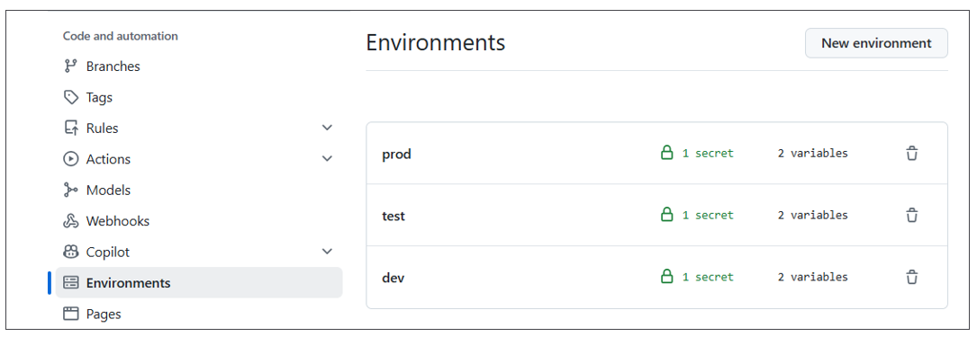
After that, you can configure each environment with the authentication credentials specific to its Entra Id tenant.
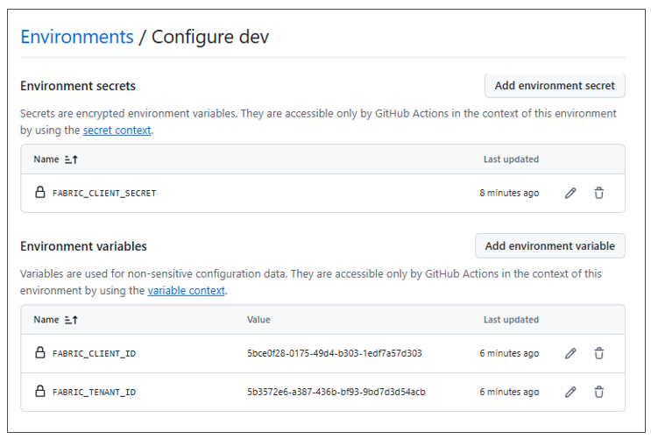
Once you have added the YAML file for a GitHub Actions workflow into the .github/workflows folder, you can view that workflow in the left navigation of the Actions page. You can also select a workflow see its run history.
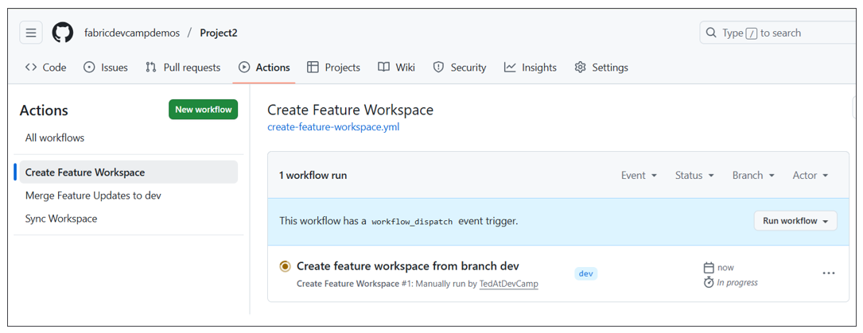
After selecting a workflow in the left navigation, you can drill into a specific workflow run and view its logs. You can also run a workflow on demand by dropping down the Run workflow menu and clicking the Run workflow button. If you need to collect information from the user before running the workflow, you can define input fields in the workflow's YAML file. The following screenshot shows an example of a workflow with input parameters that prompt the user with a textbox and two checkboxes.
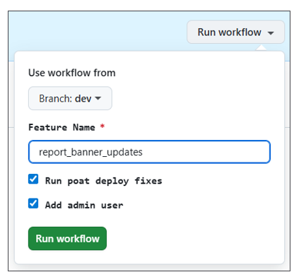
As you begin to develop GitHub Actions workflows, you should become familiar with monitoring workflow runs in order to test and debug your code. It's important to add logging to your code to report on successful operations and to display diagnostic information about any errors that occur. The following screenshot shows an example of an Azure pipeline written to log its progress in a Fabric CI/CD workflow.
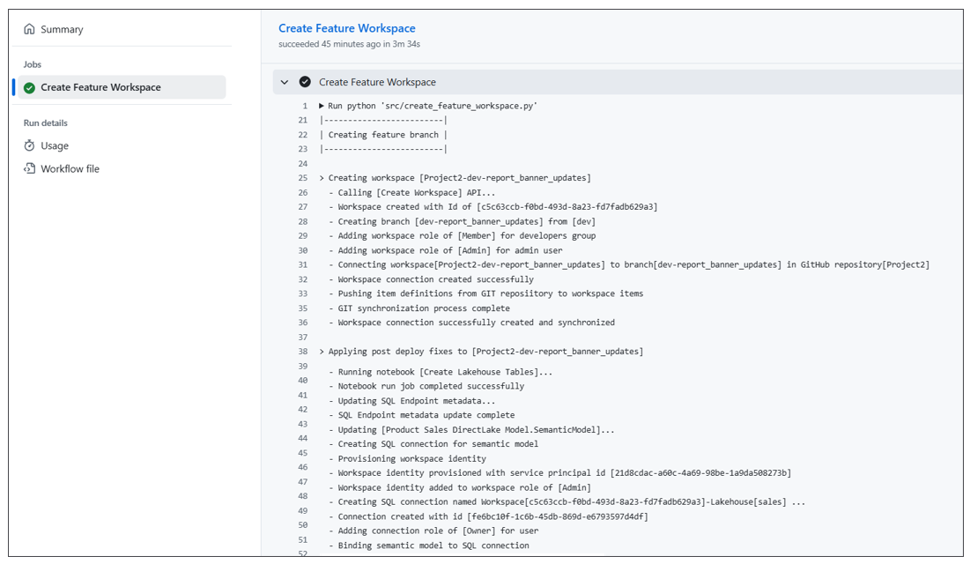
Resources for GitHub Actions Workflows
- Understanding GitHub Actions
- Workflows
- Variables
- Deployment environments

Summary
You have now completed an overview of the Fabric platform's support for CI/CD. You learned that Fabric GIT integration and the ability to connect a workspace to a GIT branch provide the foundation for continuous integration and continuous deployment. Fabric GIT integration is based on serializing workspace items into item definitions which can be written to a GIT branch as a set of item definitions. Fabric is also able to initialize an empty workspace using a set of item definitions in GIT.
You learned that deployment pipelines provide the easiest way to build a release process in Fabric for continuous deployment. You also know that GIT integration and deployment pipelines can be used together to build an end-to-end CI/CD workflow.
This overview introduced variable libraries which play an essential role in Fabric CI/CD. Variables libraries allow you to design a parameterization strategy by creating a set of variables and value sets. When used correctly, variable libraries help you to avoid writing code with hardcoded environment settings that change across environments and workspaces.
You learned there are several different approaches you can take for automating tasks in a Fabric CI/CD project. You can leverage tools and libraries like Terraform , Fabric CLI and the fabric-cicd library. You also have the ability to call Microsoft APIs directly if you feel the extra degree of control is worth the effort.
This overview introduced the workflow development environments for Azure DevOps and GitHub. The development experience in Azure DevOps is based on Azure pipelines while development experience in the GitHub is based GitHub Action workflows. Both development environments provide a similar ability to create workflows using YAML-based files and to provide your code with access to variables and secrets. You should become comfortable with writing, testing and debugging code in one of these development environments if you are the one responsible for automation in a Fabric CI/CD project.

